**Mae Fah Luang University**

**หมู่ที่ 1 333, Tha Sut, Mueang,**

**Chiang Rai District, Chiang Rai 57100, Thailand**



## 1501413 : Big Data Management and Analytics

## *Lab Report*

#### 

**Student ID: 6531501208**

**Student NAME: SAI HAE NAING LAY**

***Under the guidance of***

**Dr. Prof. Shanmugam Nandagopalan**

### 

**School of Applied Digital Technology**

**Lab - 3**

**MongoDB Tutorial**

**Statement of Problem**

MongoDB is a widely used NoSQL database that allows for flexible, document-based data storage. This lab report aims to demonstrate the installation, basic operations, and CRUD (Create, Read, Update, Delete) functionalities in MongoDB through hands-on exercises.

**Explanation of Method/Algorithm**

• Installation **of MongoDB**

* Download MongoDB Community Server from [MongoDB Official Site](https://www.mongodb.com/try/download/community).
* Install MongoDB and execute the application.

• Database **Creation**

* Open MongoDB Compass and establish a connection.
* Use the command use(database_name) to create a database.
* Create a collection using db.createCollection(collection_name).

• Data **Insertion**

* Insert a single document using:
* db.Customer.insertOne({"ID":"111", Name:"Supaphol"})
* Insert multiple documents:
* db.Customer.insertMany([{"ID":"222", Name:"Niki"}, {"ID":"333", Name:"Colins", "Zipcode":51700}])

• Querying **the Database**

* Retrieve all documents:
* db.Customer.find()
* Count total rows:
* db.Customer.find().count()
* Filter by condition:
* db.Customer.find( { Zipcode: { $eq: 51700 } } )

• Updating **Documents**

* Update a specific document:
* db.Customer.updateOne({Name:"Colins"}, {$set:{"Zipcode":51899}})

• Deleting **Documents**

* Delete one document:
* db.Customer.deleteOne({"ID":"111"})
* Delete all documents:
* db.Customer.deleteMany({})

**Complete Program/Code and Result**

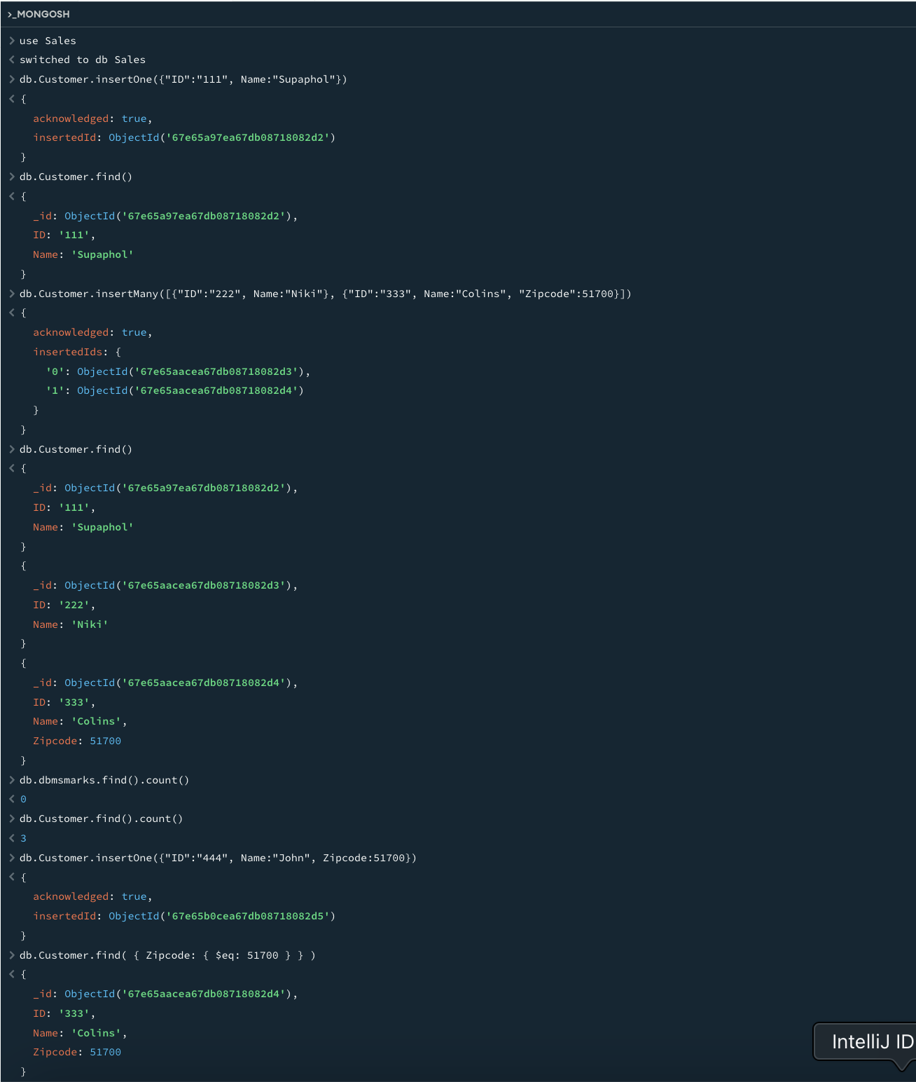

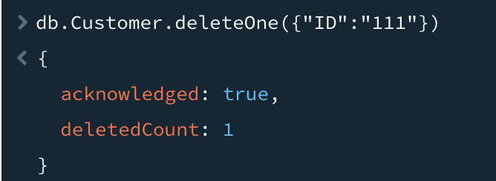

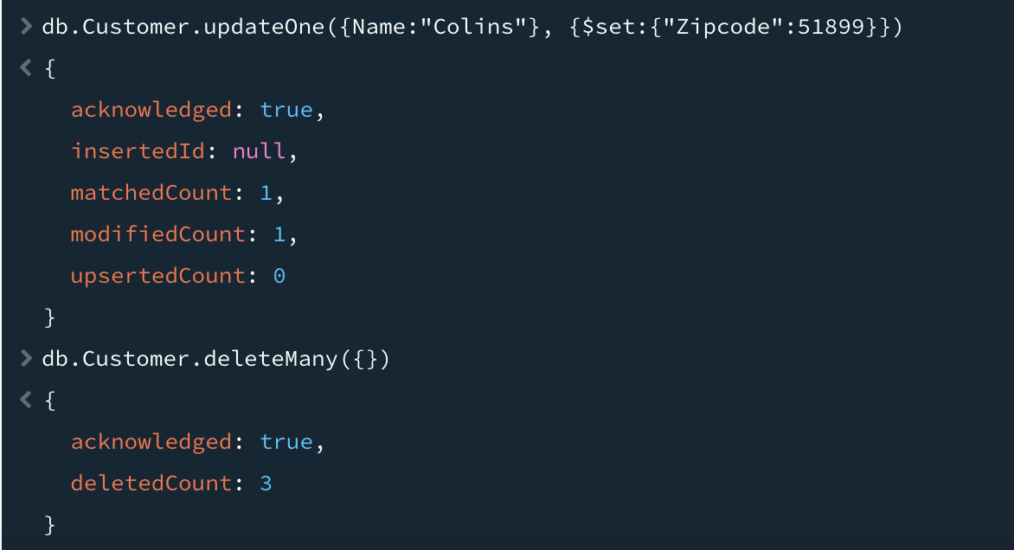

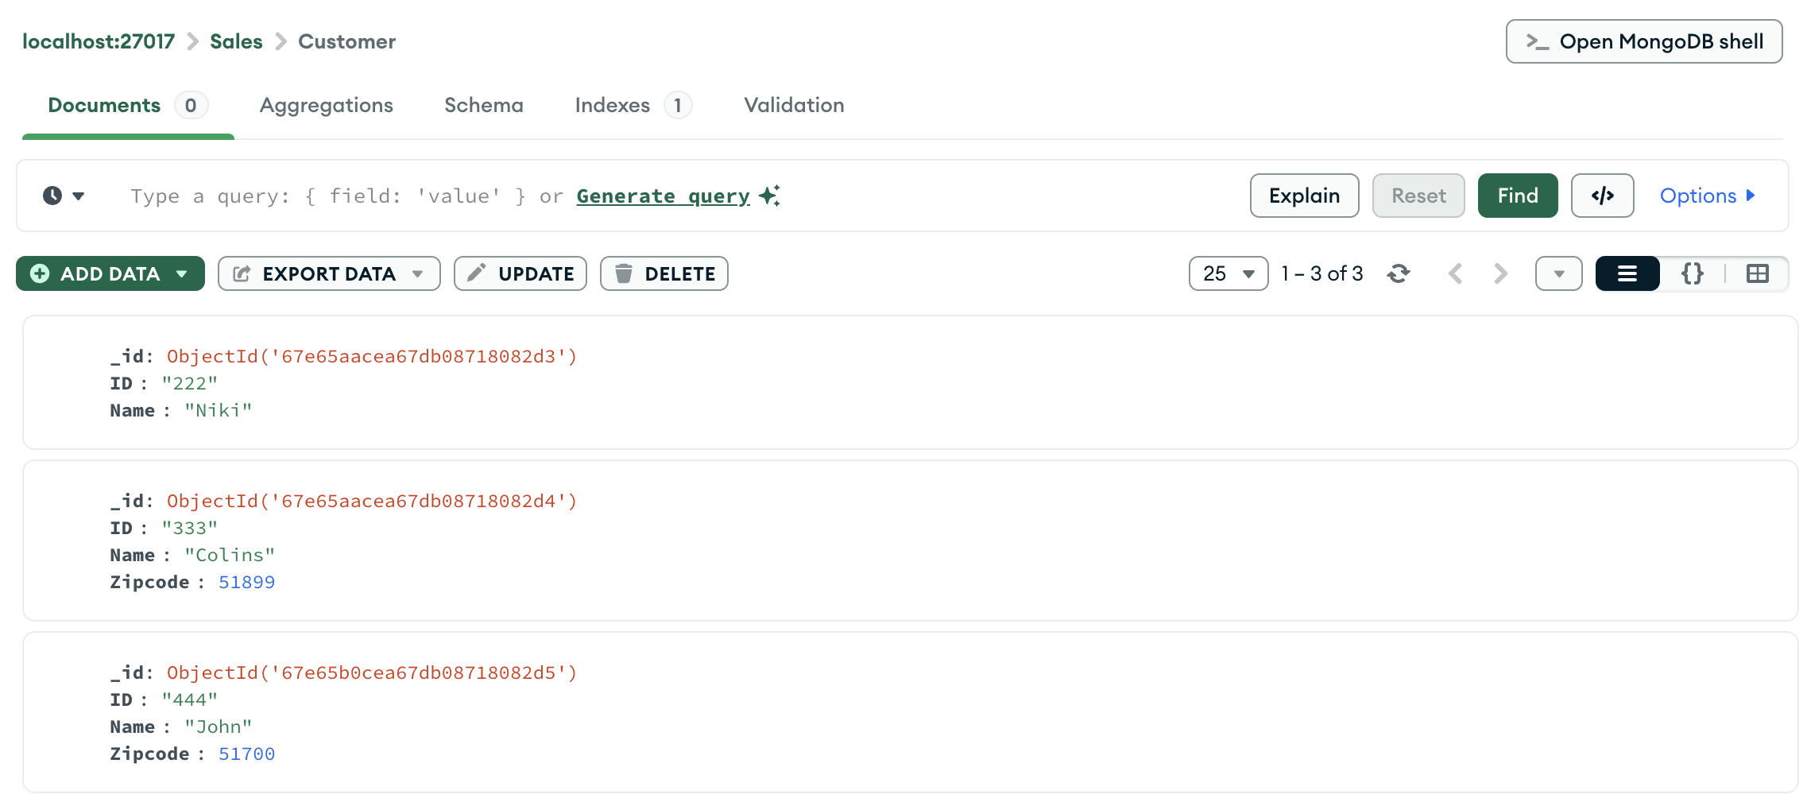

**Conclusion/ Discussion**

This lab demonstrated the essential functionalities of MongoDB, including installation, database creation, data insertion, querying, updating, and deletion. Through these exercises, we explored MongoDB's flexible schema and powerful query capabilities, making it a valuable tool for big data management.

**Lab - 4**

**Naïve Bayes Classification on Vehicle Stolen Dataset**

**Statement of Problem**

The objective of this lab is to **predict whether a vehicle has been stolen** based on its attributes such as **brand, color, and time** using **Naïve Bayes classification** in PySpark.

**Explanation of Method/ Algorithm**

• Dataset**:** The vehicle_stolen_dataset_New.csv contains vehicle data with features such as brand, color, and time.

• Preprocessing**:**

* **String Indexing**: Convert categorical variables (brand, color, time, stoled) into numerical format using StringIndexer.
* **Feature Engineering**: Use VectorAssembler to combine indexed features into a single vector.

• Splitting **Data:** The dataset is split into **training (60%) and testing (40%)**.

• Model **Selection:** The **Naïve Bayes classifier** (multinomial model type) is used for classification.

• Training**:** The model is trained using the **training dataset**.

* • Evaluation**:** The model is tested on unseen data

**Program Code**

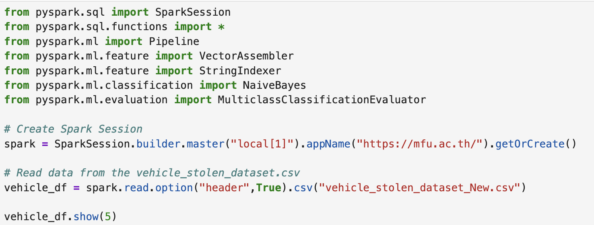

Result :  
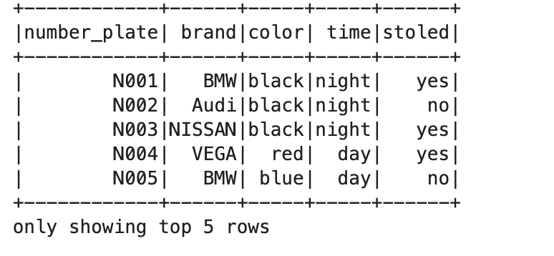

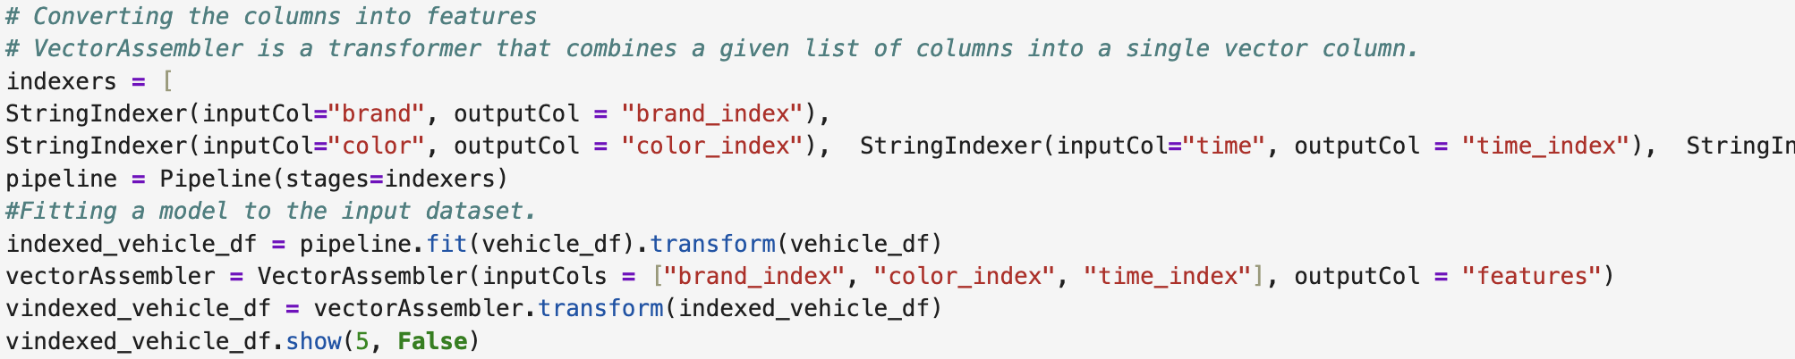

Result :

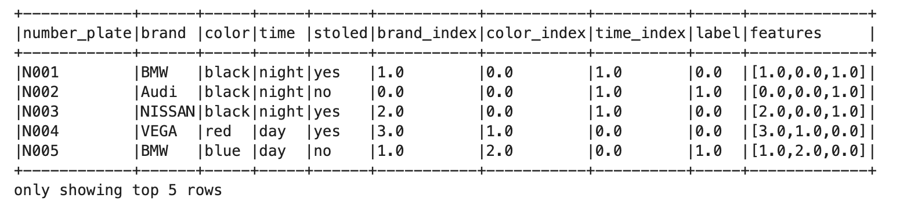

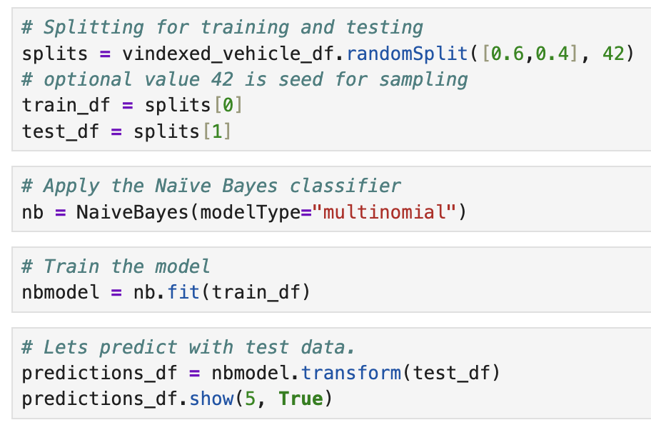

Result :

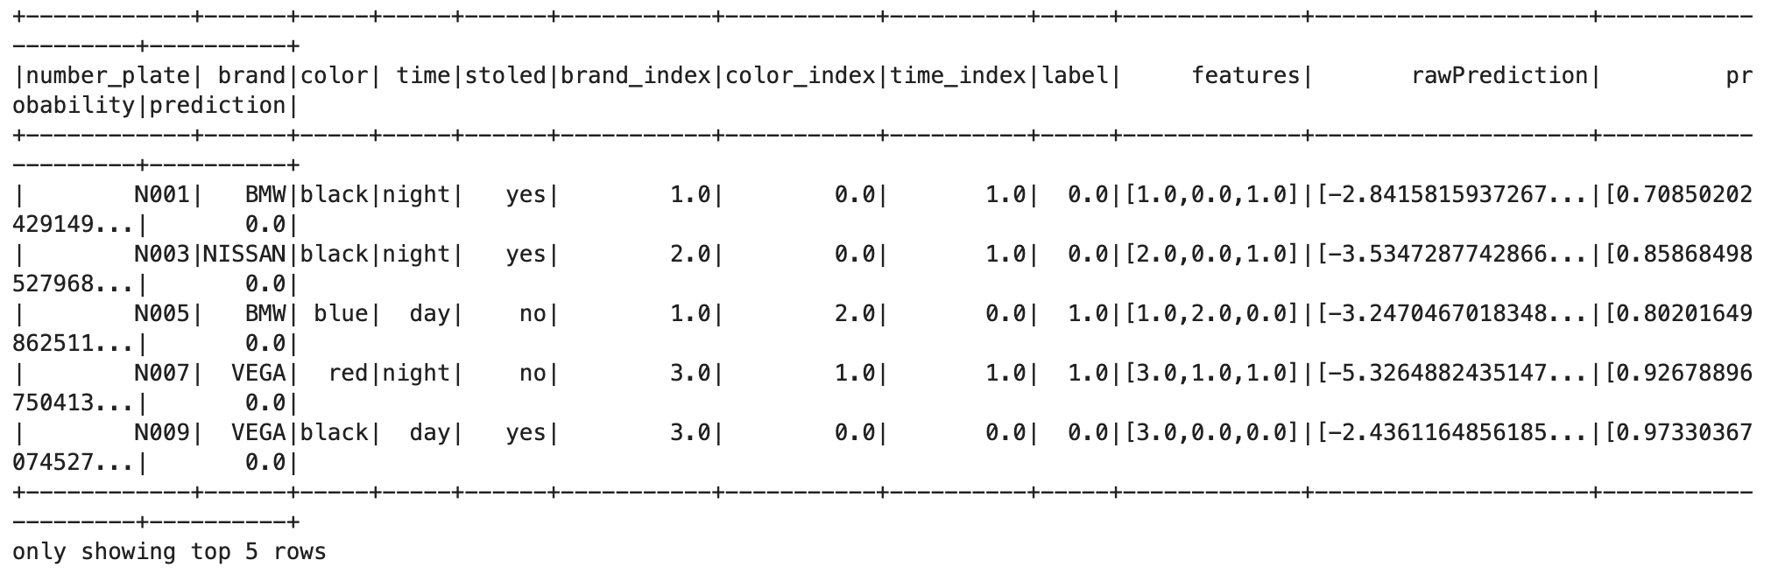



Result :

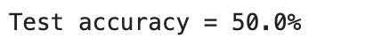

**Conclusion/ Discussion**

• The **Naïve Bayes model** was successfully applied to classify stolen vehicles.

• Model accuracy was **calculated** using the **MulticlassClassificationEvaluator**.

• Potential improvements:

* Try different **feature selections** or **more attributes**.
* Experiment with **other classifiers** like Decision Trees or Random Forest.

**Support Vector Machine (SVM) Classification**

**Statement of Problem**

The objective of this lab is to **apply an SVM model using PySpark** to classify breast cancer cases based on **medical attributes**.

**Explanation of Method/ Algorithm**

• Dataset**:** The **breast cancer dataset** is loaded from **Scikit-learn**.

• Preprocessing**:**

* The dataset is converted into a Pandas DataFrame and then transformed into a **Spark DataFrame**.
* **Feature Engineering**: VectorAssembler is used to combine all numerical features into a single vector.

• Splitting **Data:** The dataset is split into **training (90%) and testing (10%)**.

• Model **Selection:** The **Linear Support Vector Classifier (LinearSVC)** is used.

• Training**:** The model is trained using **50 iterations**.

• Evaluation**:**

* Model accuracy is measured using **MulticlassClassificationEvaluator**.
* A **confusion matrix** is generated.

**Complete Program/Code**

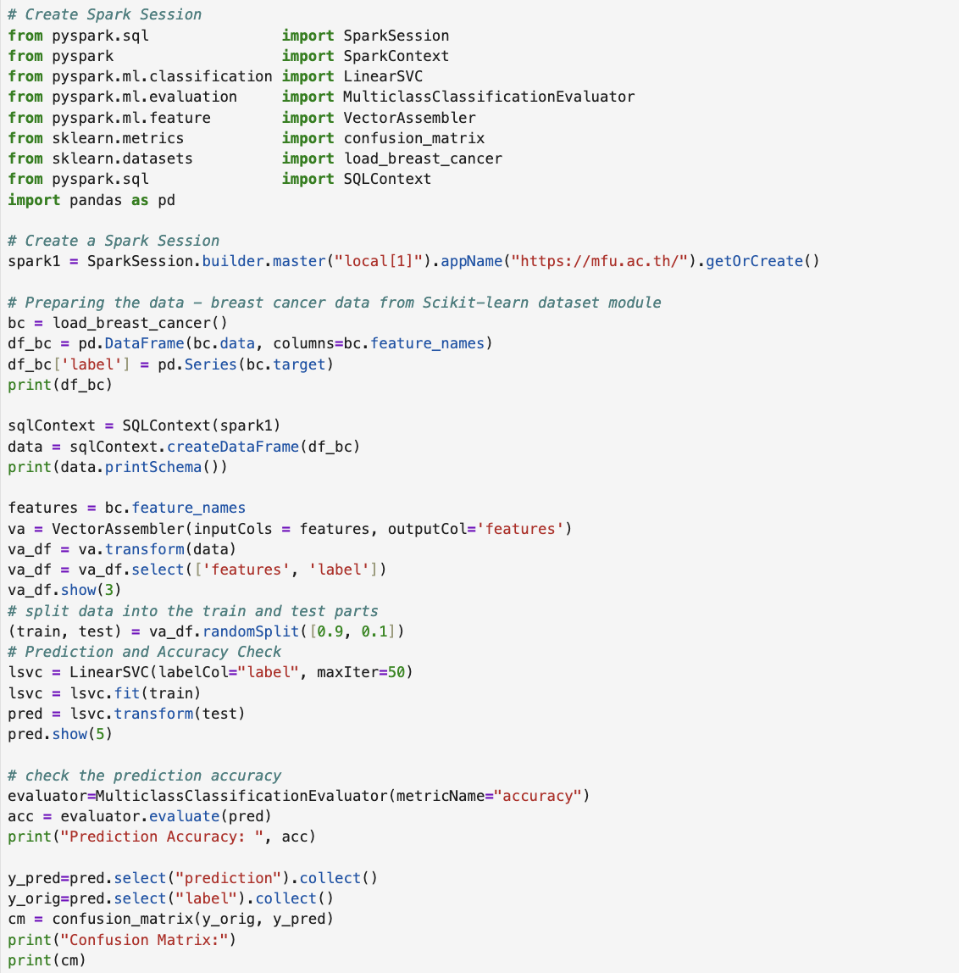

Result :   
  
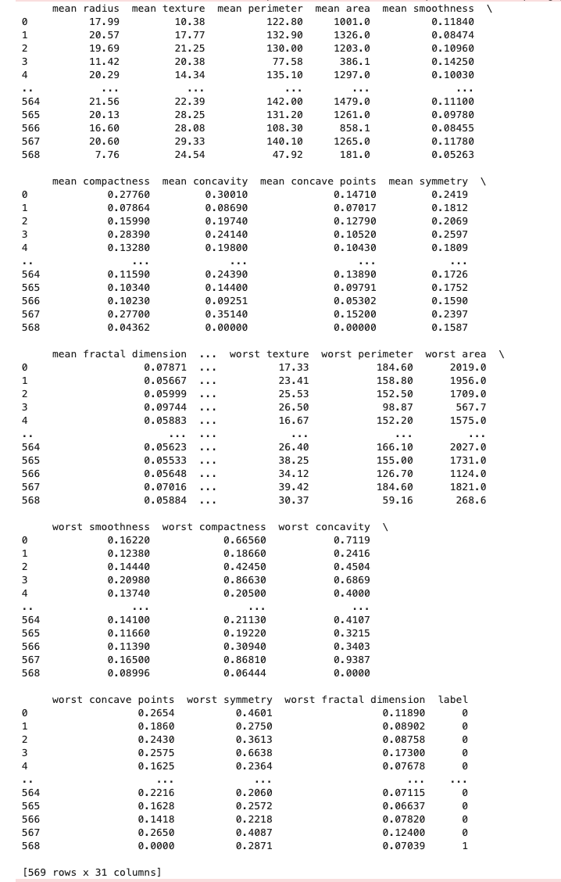

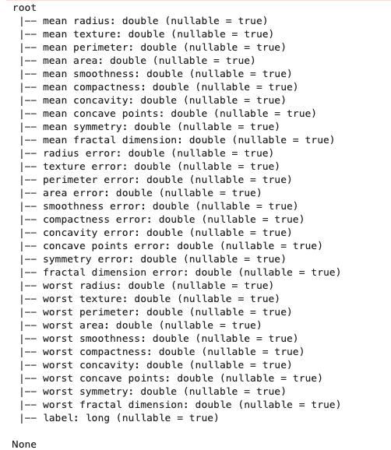

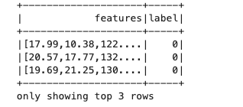

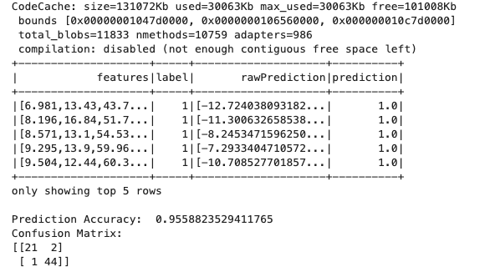

**Conclusion/ Discussion**

• The **Linear Support Vector Classifier (SVM)** successfully classified breast cancer cases.

• Model **accuracy** was calculated using MulticlassClassificationEvaluator.

• The **confusion matrix** shows classification performance.

• Potential improvements:

* Tune **hyperparameters** (e.g., maxIter, regularization).
* Use **kernelized SVM models** if needed.

**Lab 5**

**K-Means Clustering**

**Statement of Problem**

The objective of this lab is to **apply K-Means clustering** on a small dataset with **X, Y coordinates** and visualize the results.

**Explanation of Method/ Algorithm**

• **Dataset:**

* The input dataset consists of **eight points** in a **2D space (X, Y)**.

• **Feature Engineering:**

* VectorAssembler is used to **combine numerical columns** (X, Y) into a **feature vector**.

• **Model Selection:**

* **K-Means clustering** is applied with **k = 3 clusters**.

• **Training:**

* The model is trained on the transformed dataset.

• **Cluster Assignments:**

* The model assigns each data point to a **cluster**.

• **Visualization:**

* The clustered data is **converted into a Pandas DataFrame**.
* A **scatter plot** visualizes the clustering results.

**Program Code**

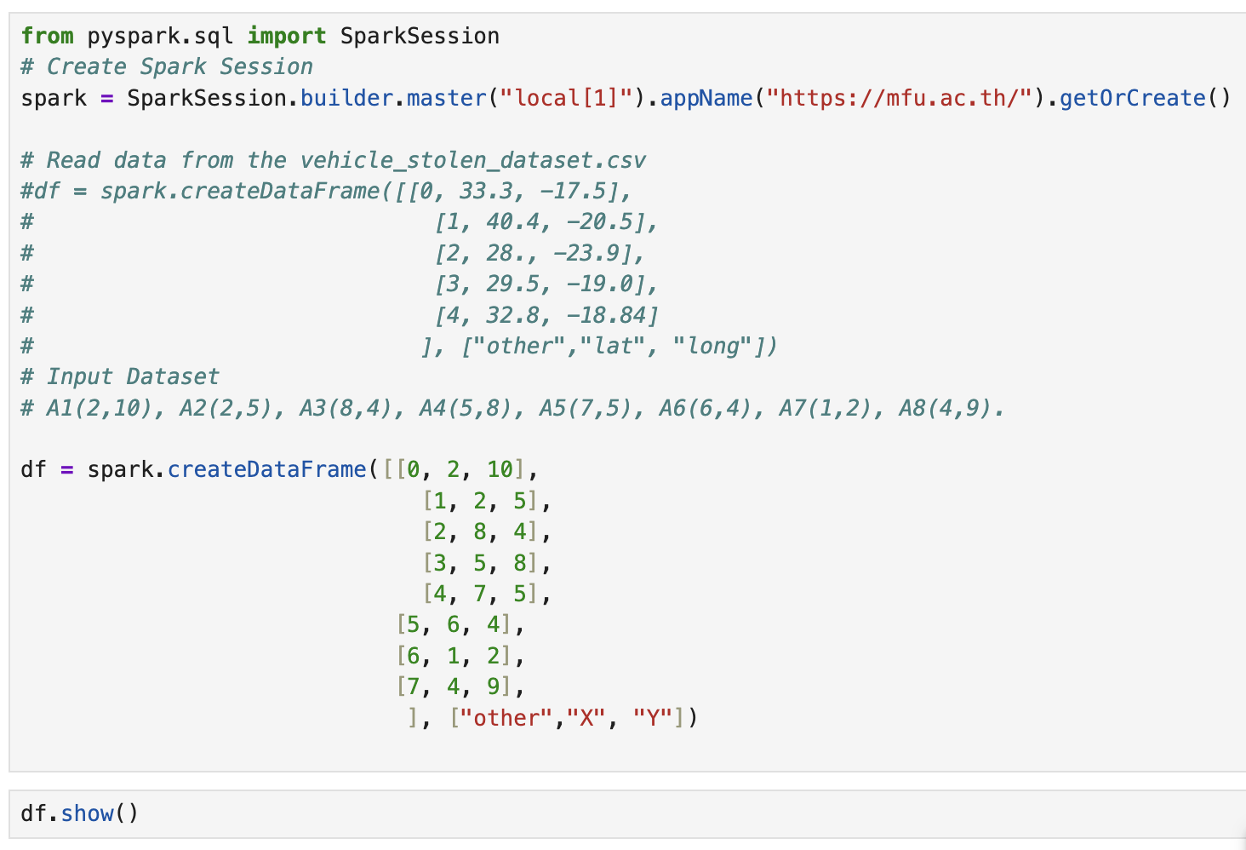

Result :

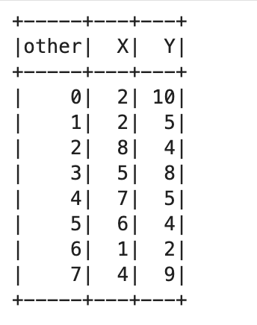

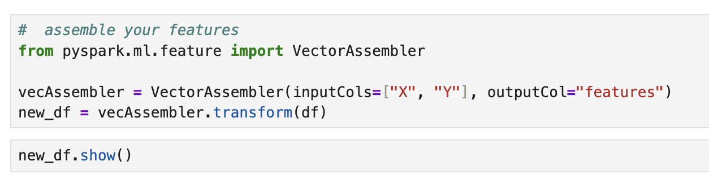

Result :

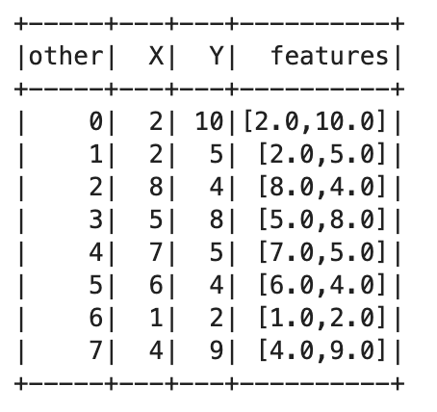

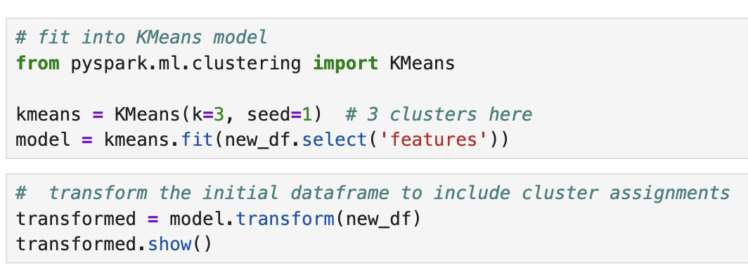

Result :

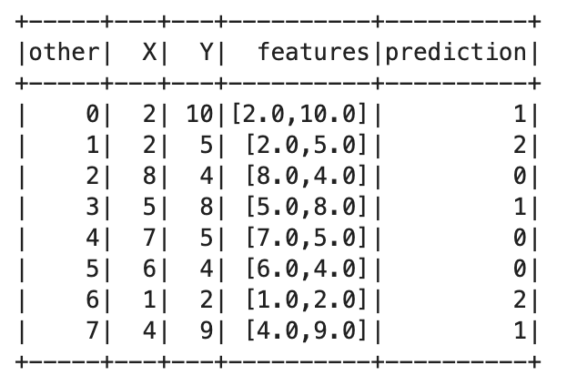

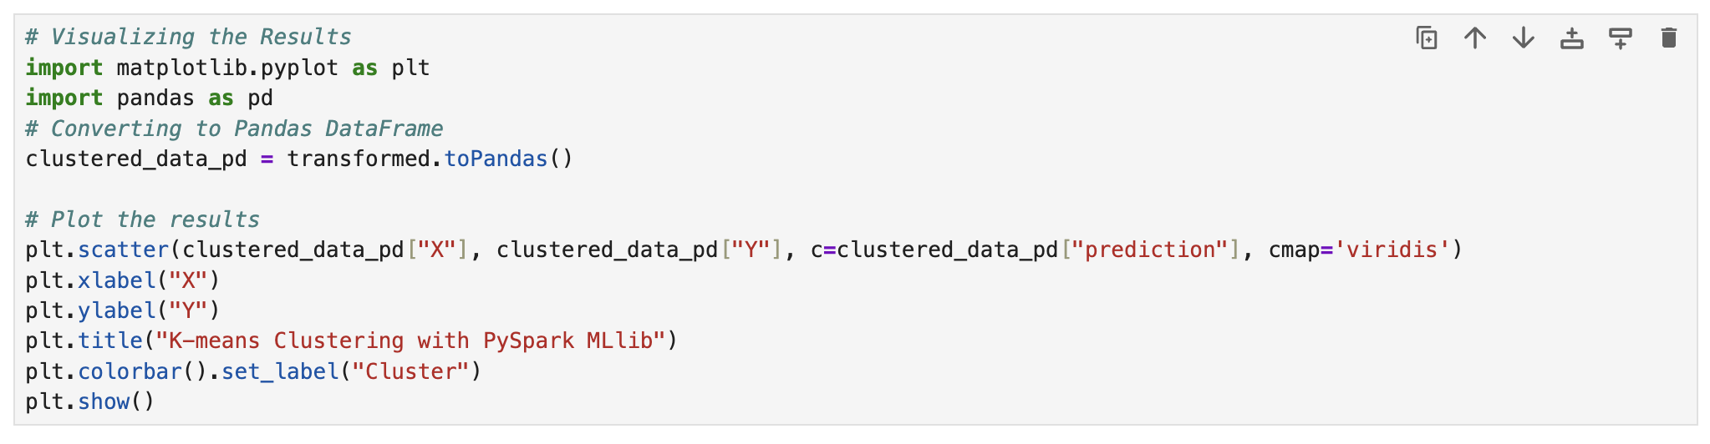

Result :

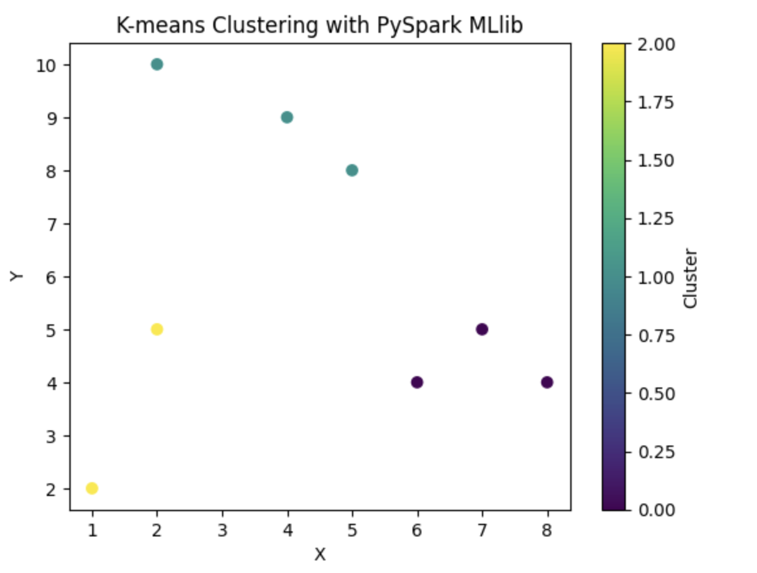

**Conclusion**

• The **K-Means model** successfully clustered the **2D data points**.

• The **scatter plot** visually confirms the **three clusters**.

• Potential improvements:

* Experiment with **different values of k**.
* Use **elbow method** to find the optimal k.
* Apply **real-world datasets** for clustering.

**K-Means Clustering with PCA for Live Sellers Data**

**Statement of Problem**

The objective of this lab is to **cluster live sellers** based on their **engagement metrics** (likes, reactions, comments, shares, and loves) using **K-Means clustering and PCA**.

**Explanation of Method/ Algorithm**

• Dataset**:** Live_Sellers_Thailand.csv

* Contains **engagement metrics** like num_reactions, num_comments, num_shares, num_likes, and num_loves.

• Feature **Engineering:**

* VectorAssembler is used to **combine numerical columns** into a **single feature vector**.

• Model **Selection:**

* **K-Means clustering** with k = 4 clusters.

• Training**:**

* The model is trained on the transformed dataset.

• Dimensionality **Reduction (PCA):**

* The data is reduced to **2 principal components** (PC1, PC2) for visualization.

• Visualization**:**

* A **scatter plot** of clustered data using seaborn.

**Program Code**

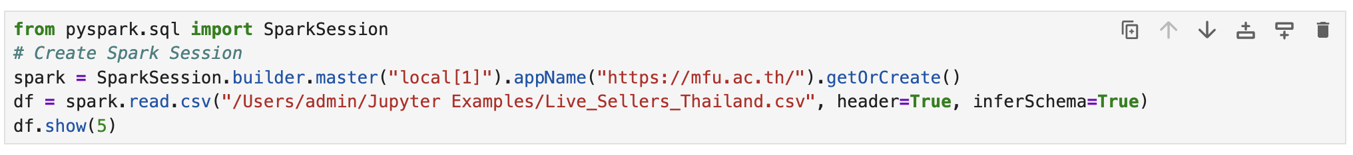

Result :

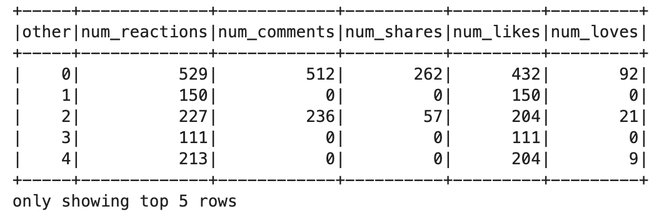

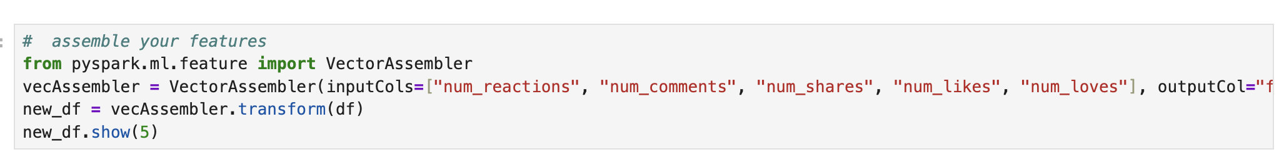

Result :

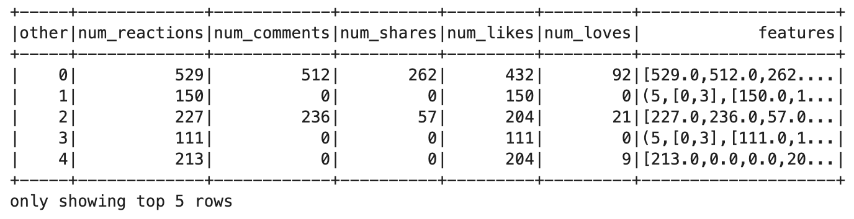

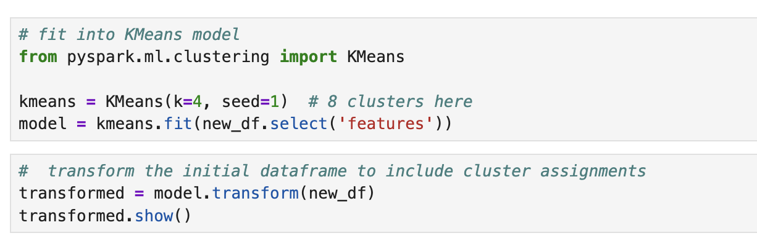

Result :

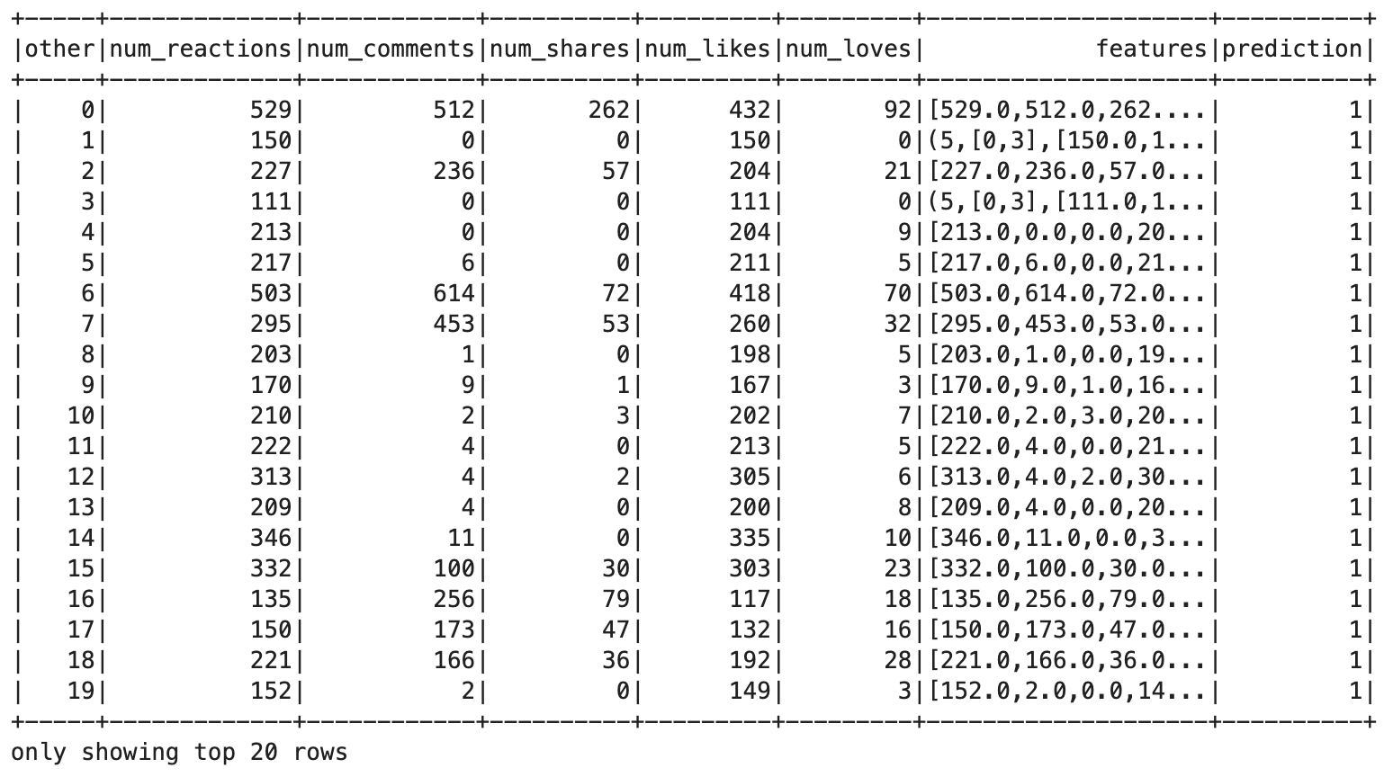

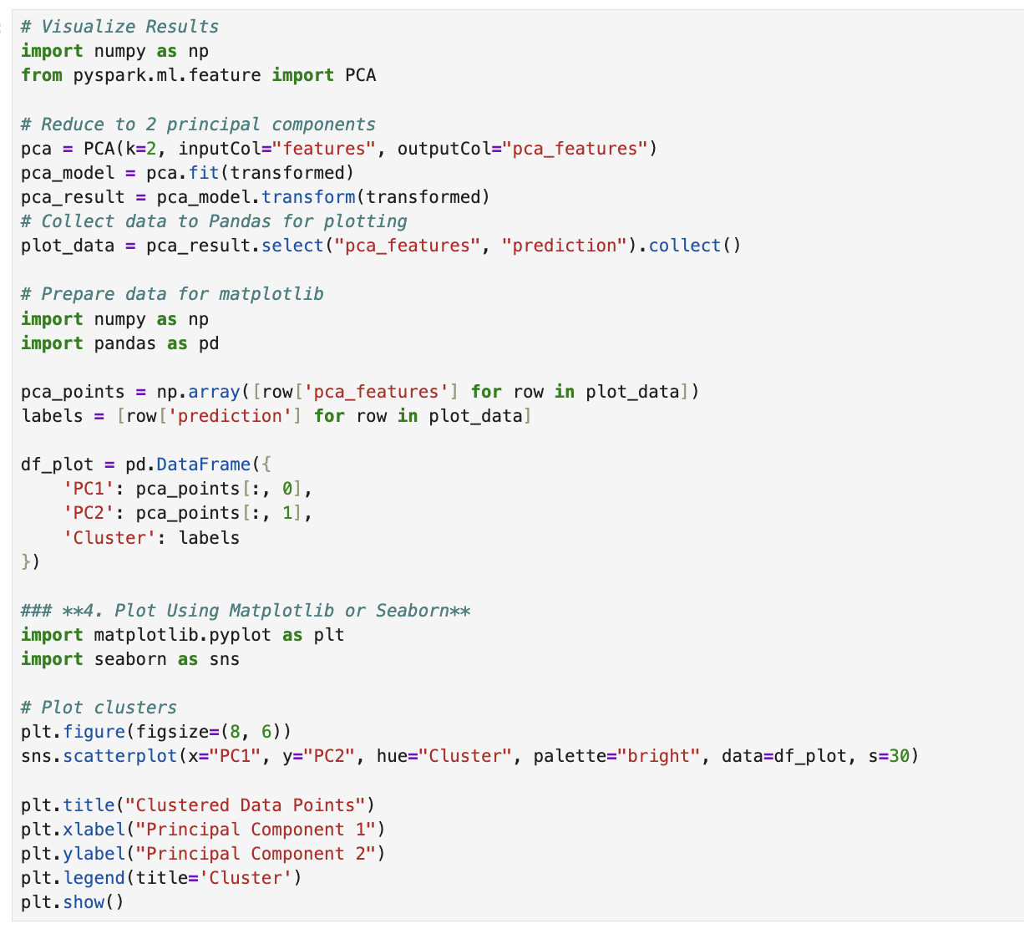

Result :

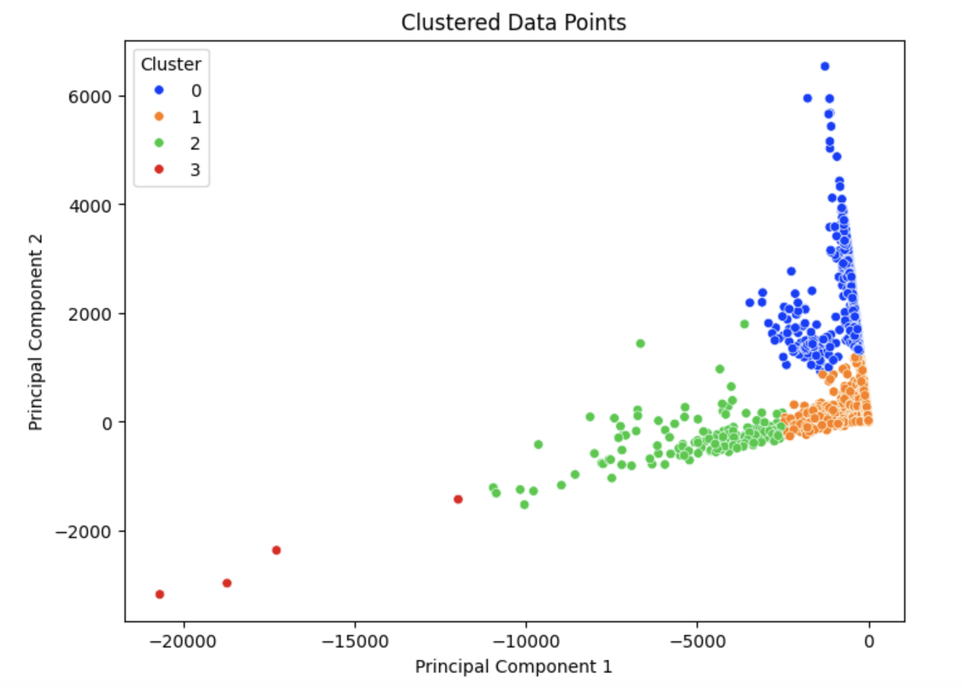

**Conclusion**

• The **K-Means model** successfully clustered **live sellers** based on engagement metrics.

• PCA helped **visualize high-dimensional data** in **2D space**.

• Potential improvements:

* Tune k using the **Elbow Method**.
* Normalize data before applying K-Means.
* Use **alternative clustering techniques** like **DBSCAN**.

**Lab - 6**

**Market Basket Analysis Using Pyspark**

**Statement of Problem**

The objective of this lab is to **perform market basket analysis** using **Frequent Pattern Growth (FP-Growth)** on a dataset of transactions and identify **association rules** among frequently purchased items.

**Explanation of Method/Algorithm**

• Dataset**:** basket.csv

* Each row represents a **basket of purchased items**.

• Data **Preprocessing:**

* **Assigns unique IDs** to each transaction.
* Uses **Array transformation** to combine basket items.
* **Removes NULL values** from the basket list.

• Model **Selection:**

* **FP-Growth algorithm** is used to identify **frequent itemsets** and **association rules**.

• Training**:**

* Minimum Support: 0.001
* Minimum Confidence: 0.001

• Model **Outputs:**

* **Frequent itemsets** (items frequently bought together).
* **Association rules** (if a customer buys X, they are likely to buy Y).

• Testing**:**

* A **new dataset of shopping baskets** is transformed using the trained model.

**Complete Program/Code**

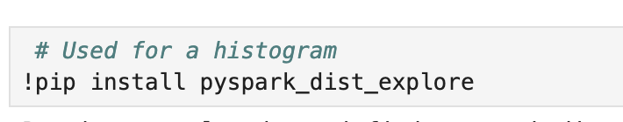

**Result:**

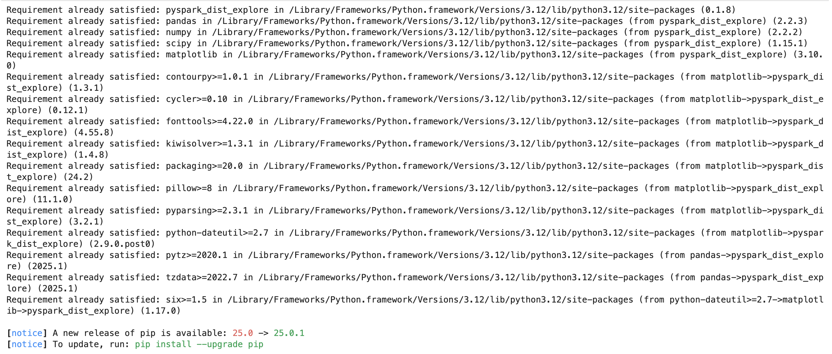

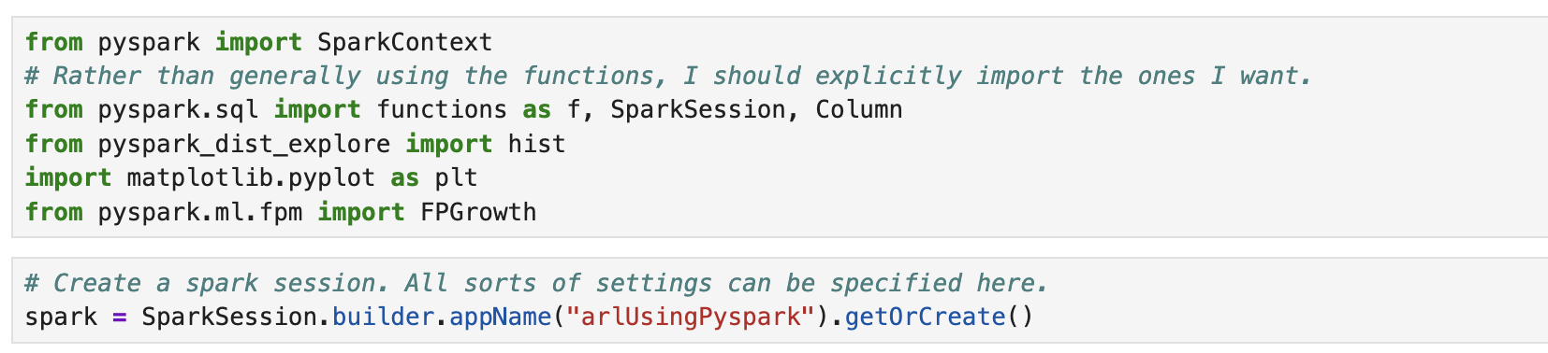

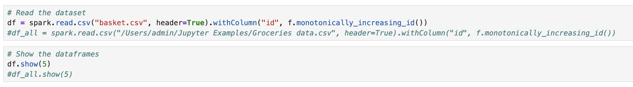

**Result:**

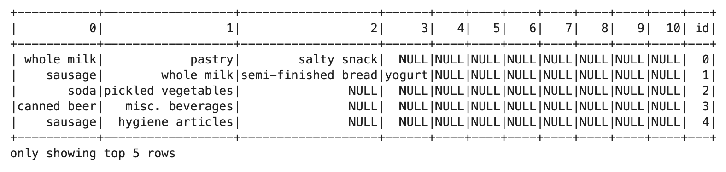

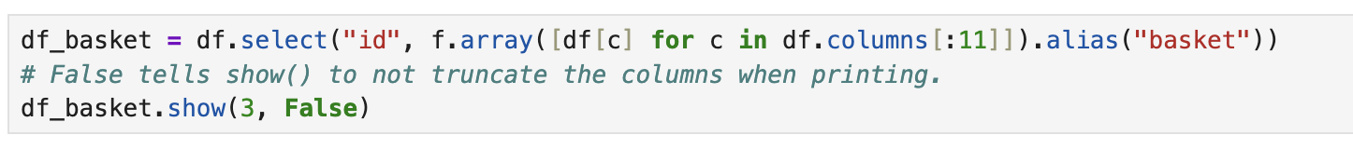

**Result:**

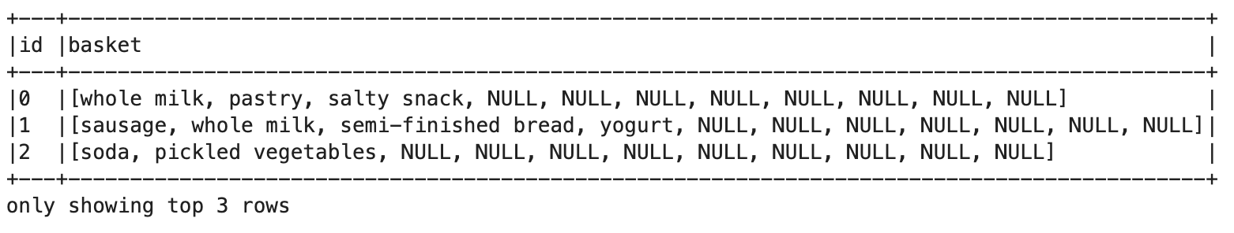



**Result:**

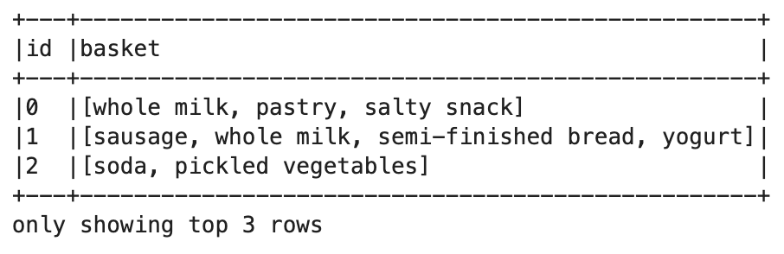

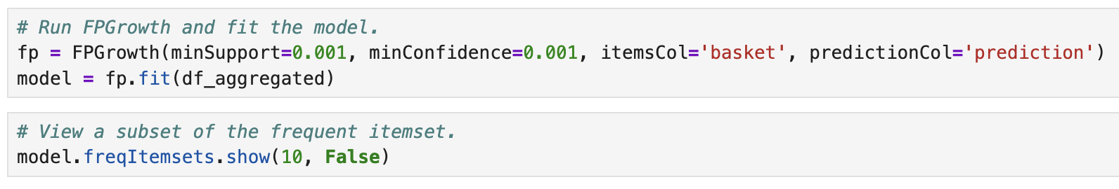

**Result:**

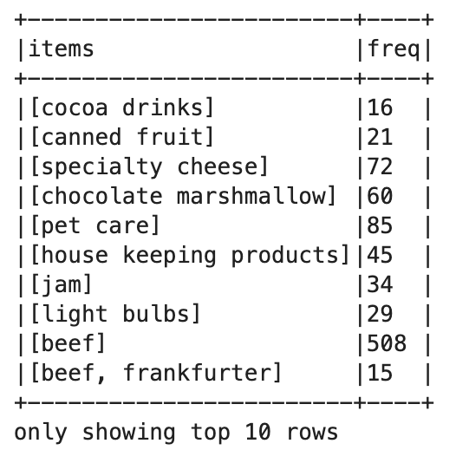



**Result:**

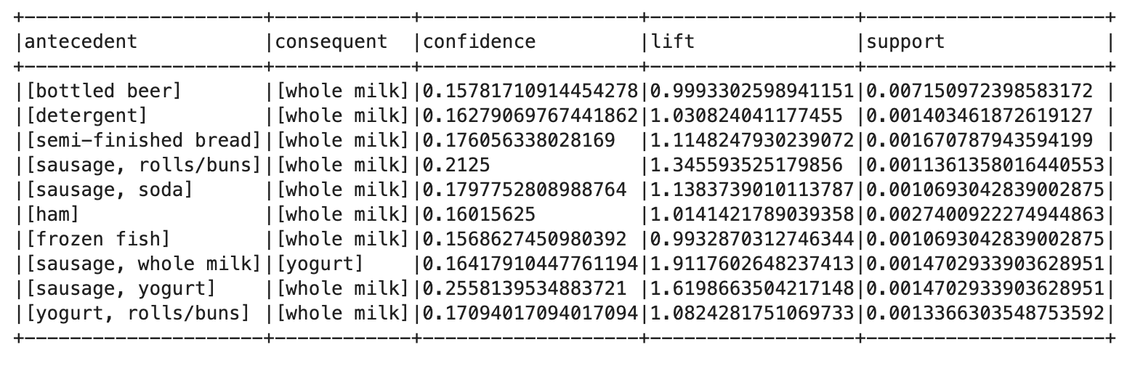

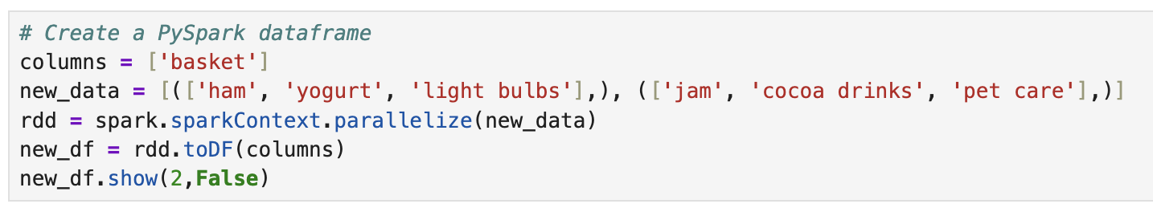

**Result:**

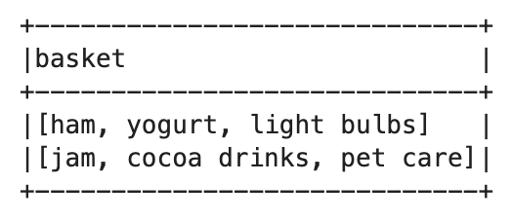

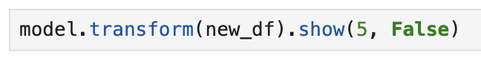

**Result:**

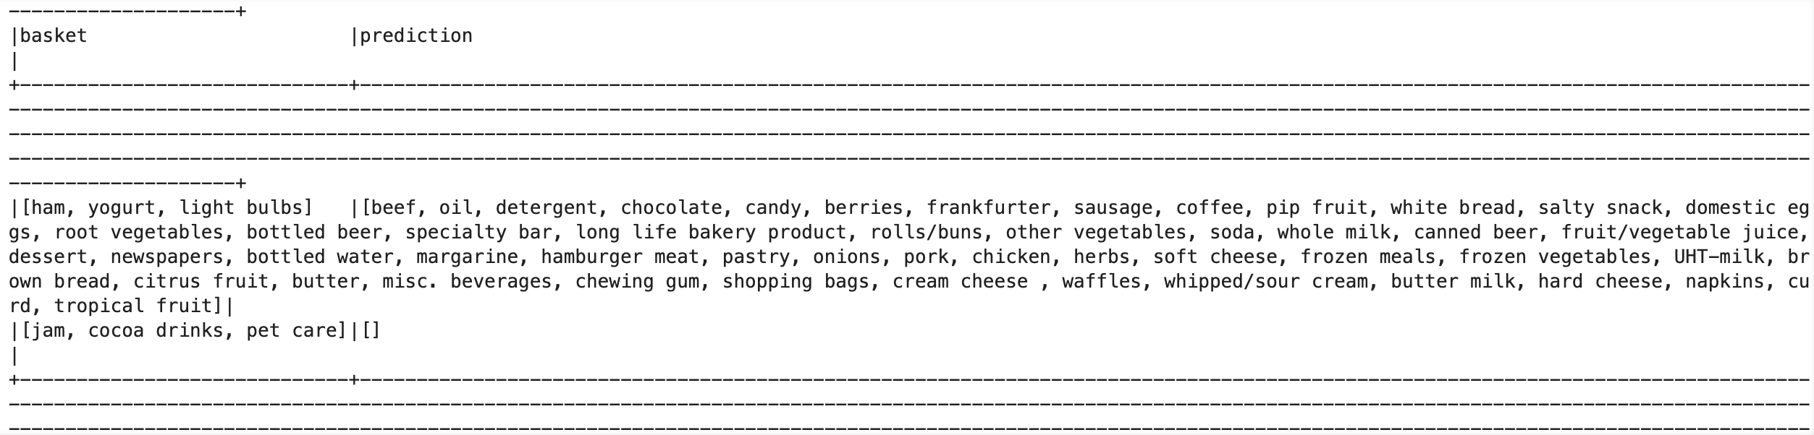

**Conclusion/Discussion**

• The **FP-Growth model** successfully identified **frequent itemsets and association rules**.

• The model can **predict additional items** based on **customer purchase history**.

• Potential improvements:

* Tune minSupport and minConfidence values.
* Use **larger datasets** to improve accuracy.
* Apply **Apriori algorithm** for comparison.

**Lab - 7**

**Kafka Structured Streaming with Pyspark**

**Statement of Problem**

The objective of this lab is to **produce and consume real-time messages** using **Apache Kafka** and **PySpark Structured Streaming**.

**Explanation of Method/Algorithm**

• Kafka **Producer:**

* **Creates a Kafka producer** using KafkaProducer.
* Sends **JSON-encoded messages** to a **Kafka topic (test)**.

• Kafka **Consumer (PySpark Structured Streaming):**

* Uses SparkSession with **Kafka dependencies** to read real-time messages.
* **Subscribes to the test topic** and listens for incoming messages.

• Message **Structure:**

* Messages include an **ID, timestamp, and text message**.
* Messages are sent in a **loop (10 messages total)**.

• Streaming **Data Processing:**

* Messages are **continuously consumed** in real-time.

**Complete Program/Code**

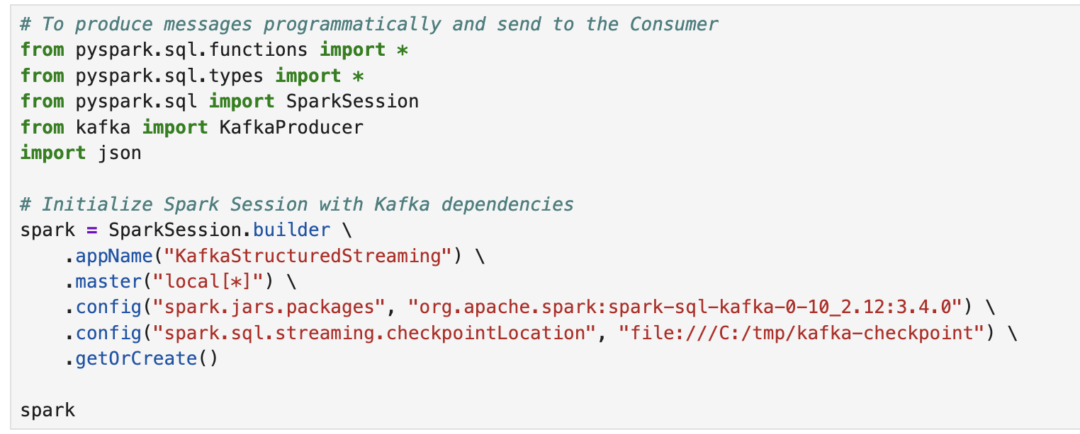

**Result:**

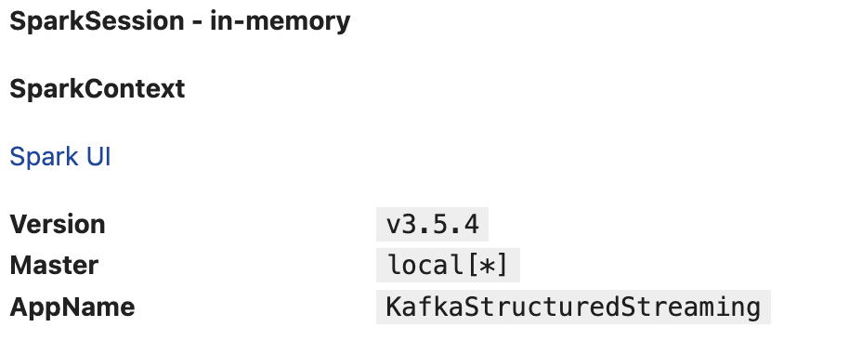

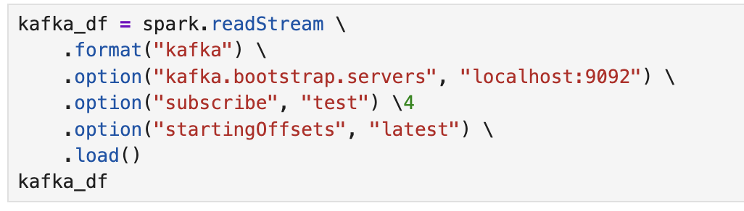

**Result:**



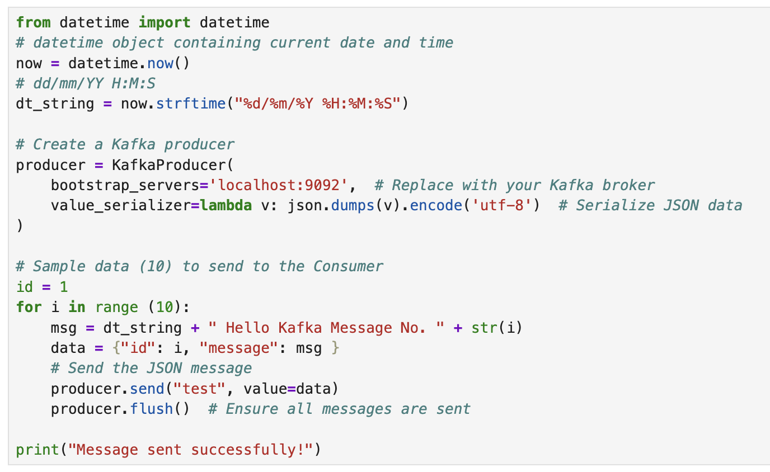

**Result:**

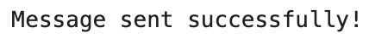

**Conclusion/Discussion**

• The **Kafka producer** successfully sent **real-time messages** to the test topic.

• **PySpark Structured Streaming** successfully **consumed and processed the messages**.

• Potential improvements:

* Use **Kafka consumer transformations** (filter, aggregation).
* Store processed messages in a **database or real-time dashboard**.
* Implement **error handling** in Kafka producer and consumer.

**Lab - 8**

**Spark SQL with CSV Files**

**Statement of Problem**

The goal of this lab is to practice **reading structured data** from CSV files using **Spark**, and then query it using **DataFrame API and SQL syntax**. This includes selecting records, filtering data, aggregating results, and performing join operations.

**Explanation of Method/ Algorithm**

• Dataset **1:** simple-zipcodes.csv — contains city, state, zip code, and country data.

• Dataset **2:** state-population.csv — contains state and population data.

• Tasks **Performed:**

* Load CSV files as DataFrames.
* Create **temporary views** for SQL querying.
* Execute **SQL and DataFrame API** queries including SELECT, WHERE, and GROUP BY.
* Perform an **inner join** between ZIPCODES and POPULATIONS tables based on the state.
* Attempt to use **Scala-style case class** to define housing data (for advanced use in Scala/Spark).

**Complete Program/Code**

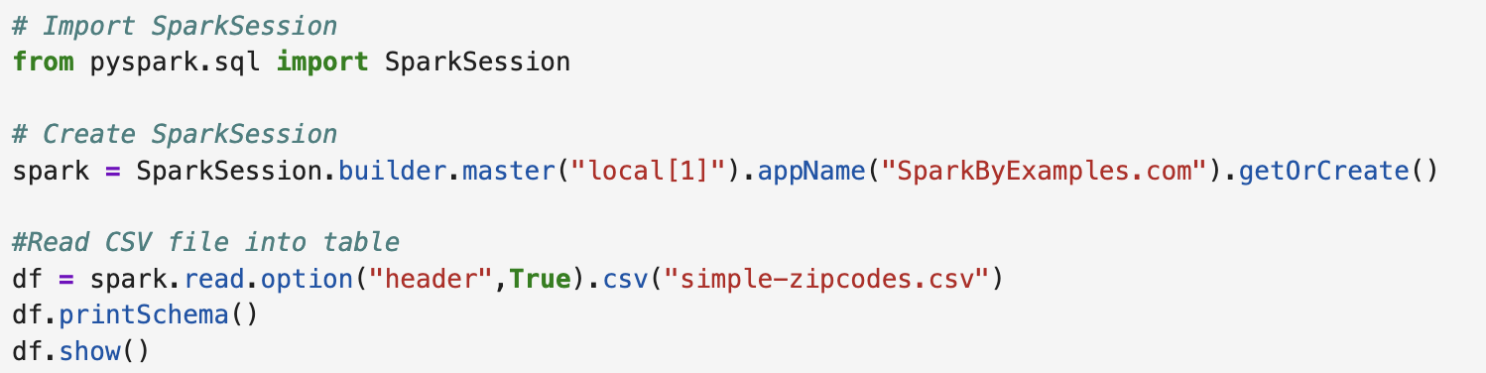

**Result:**

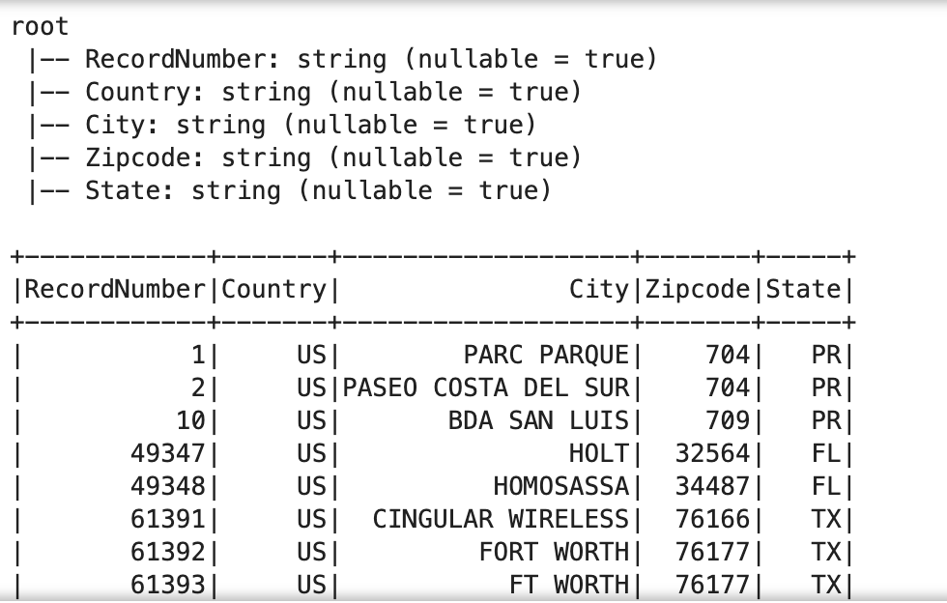

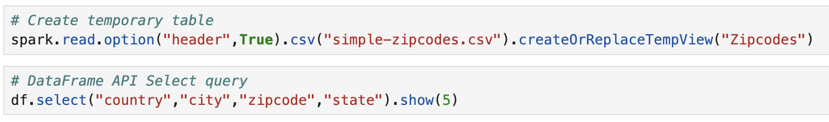

**Result:**

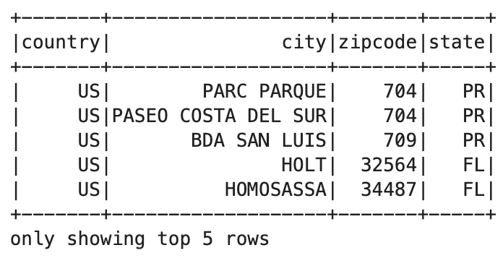



**Result:**

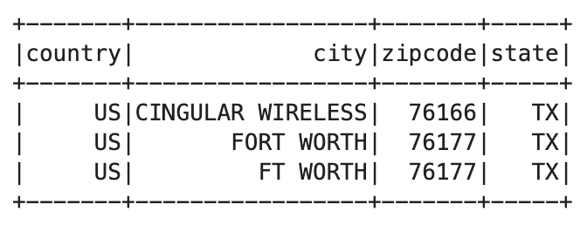



**Result:**

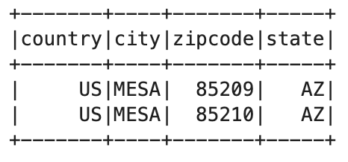

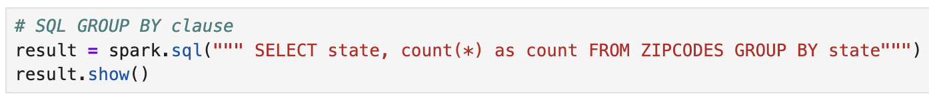

**Result:**  
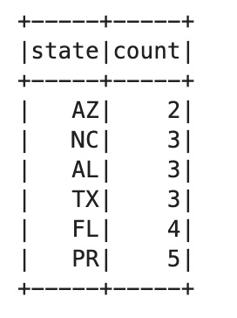

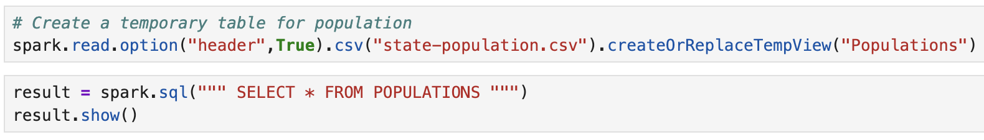

**Result:**

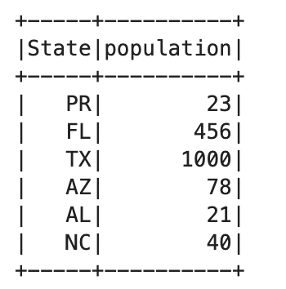

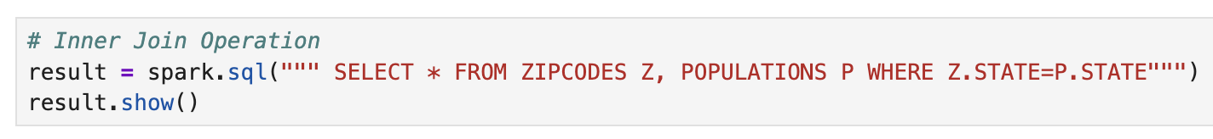

**Result:**

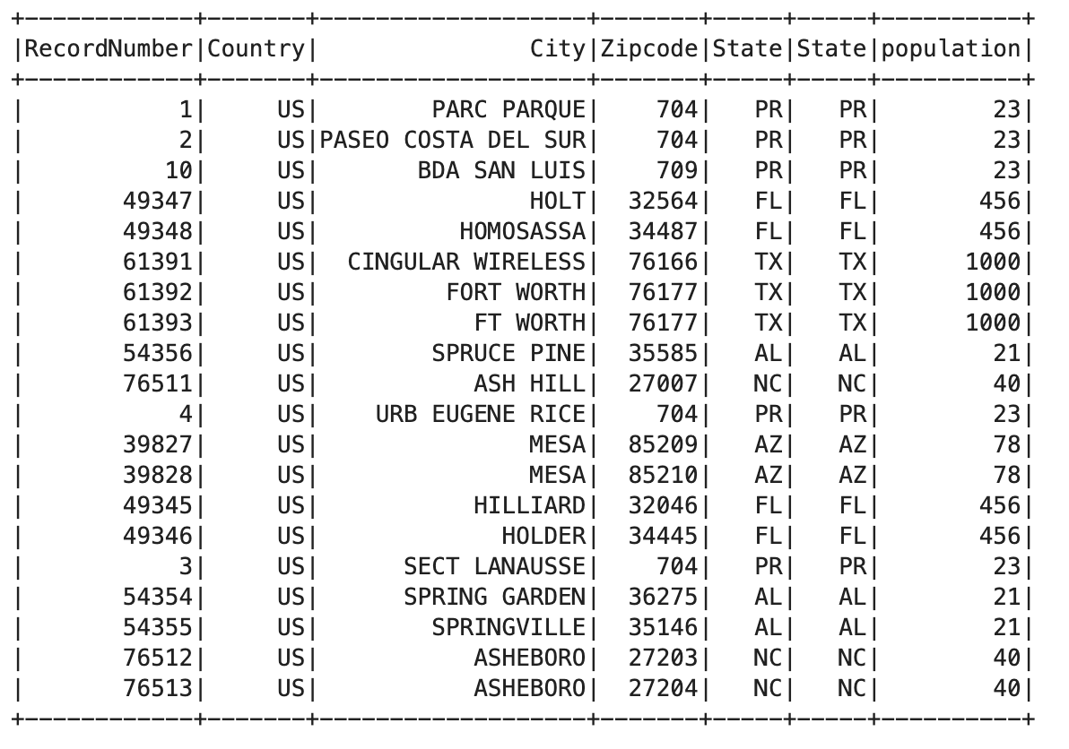  
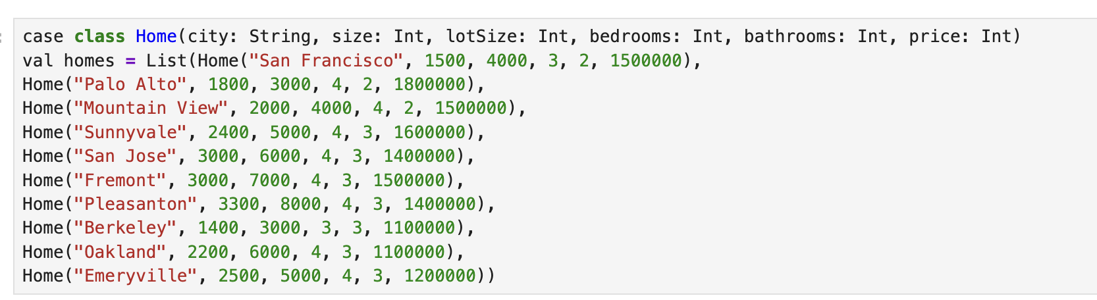

**Result:**



**Conclusion/ Discussion**

• Spark SQL successfully allowed querying of **structured data from CSV files**.

• SQL operations like WHERE, GROUP BY, and JOIN worked seamlessly.

• The **DataFrame API** and **SQL syntax** can be used interchangeably in PySpark.

• Future improvements:

* Include more complex queries.
* Try **window functions** or **data visualization** for better insights.
* Convert Scala logic to Python if needed.

**Lab – 9**

**SparkSession Behavior in Scala**

**Statement of Problem**

The goal of this lab is to **observe and explain SparkSession’s singleton behavior** when attempting to create multiple Spark applications within the same JVM process.

**Explanation of Method/ Algorithm**

• Language **Used:** Scala (SparkDemo.scala)

• Primary **Objective:**

* Create one SparkSession, then try to create another one with a different app name.

• What **We Observed:**

* The second SparkSession creation did **not generate a new session**.
* Instead, **Spark returned the existing session**.

• Reason**:** Spark maintains **only one active SparkSession per JVM** via the getOrCreate() method.

**Complete Program/ Code**

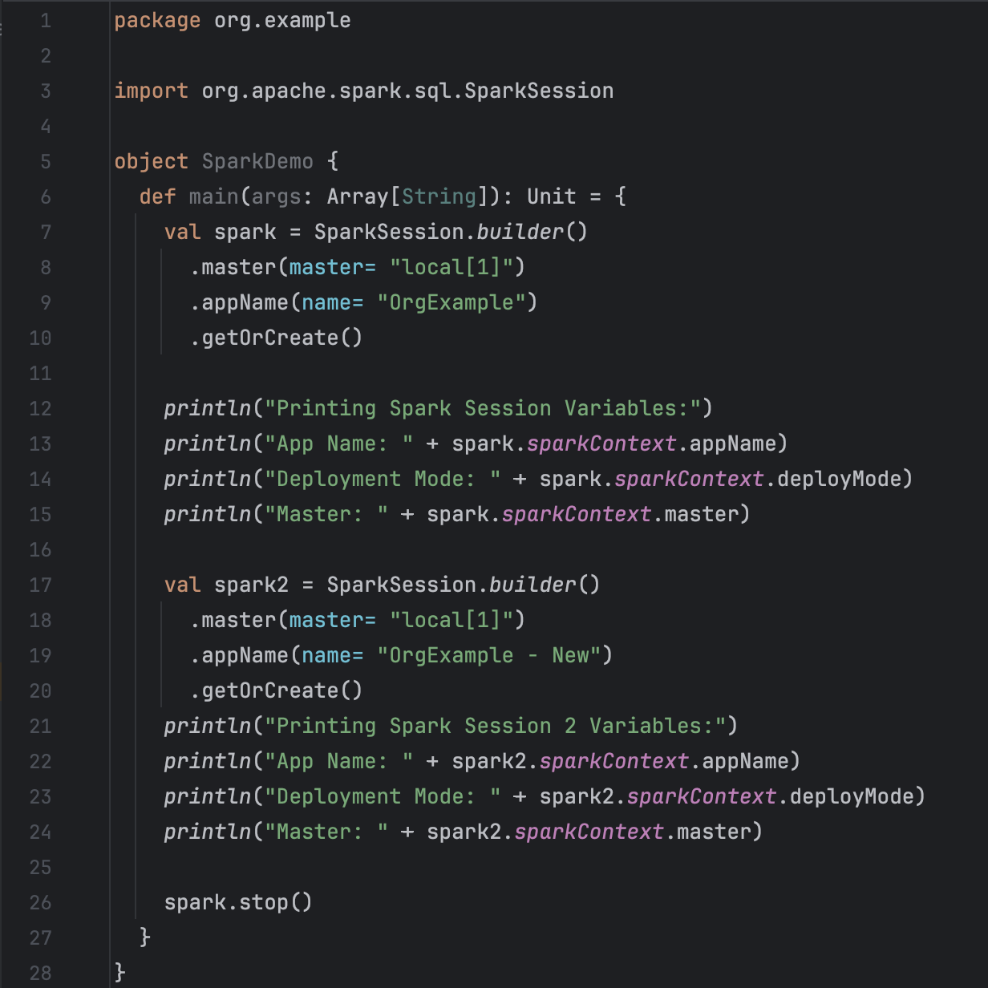

**Result:**

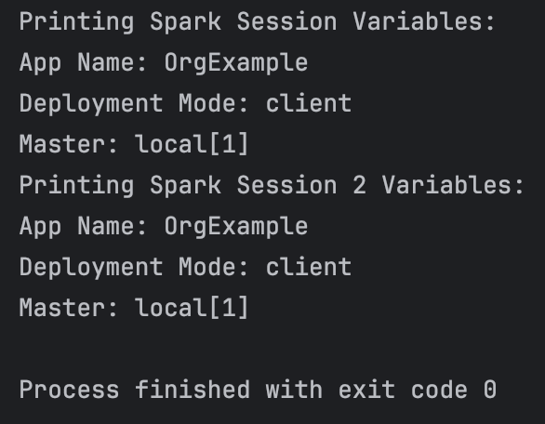

**Conclusion / Discussion**

• When using SparkSession.builder().getOrCreate(), **only one session** is active per JVM.

• Even with a new app name, Spark returns the **existing session**.

• To create a completely **independent SparkSession**, it must be done in a **new JVM process** (e.g., separate application or shell).

• This design ensures **resource consistency** and **prevents accidental SparkContext duplication**.

**Spark SQL with Scala**

**Statement of Problem**

The goal of this lab is to **demonstrate how to use Spark SQL** to:

* Create a **DataFrame from Scala collections**.
* Register a **temporary table** for SQL queries.
* Perform **SELECT and GROUP BY operations**.

**Explanation of Method/ Algorithm**

• Data **Source:** Hardcoded employee data in a Scala Seq collection.

• Steps **Performed:**

* Initialize **SparkSession**.
* Create a **DataFrame with employee details** (sno, name, deptid).
* Register the DataFrame as a **temporary SQL table**.
* Run **SQL queries**:
  + SELECT * FROM My_Spark_Table → Displays all records.
  + GROUP BY deptid → Counts employees per department.

**Complete Program/ Code**

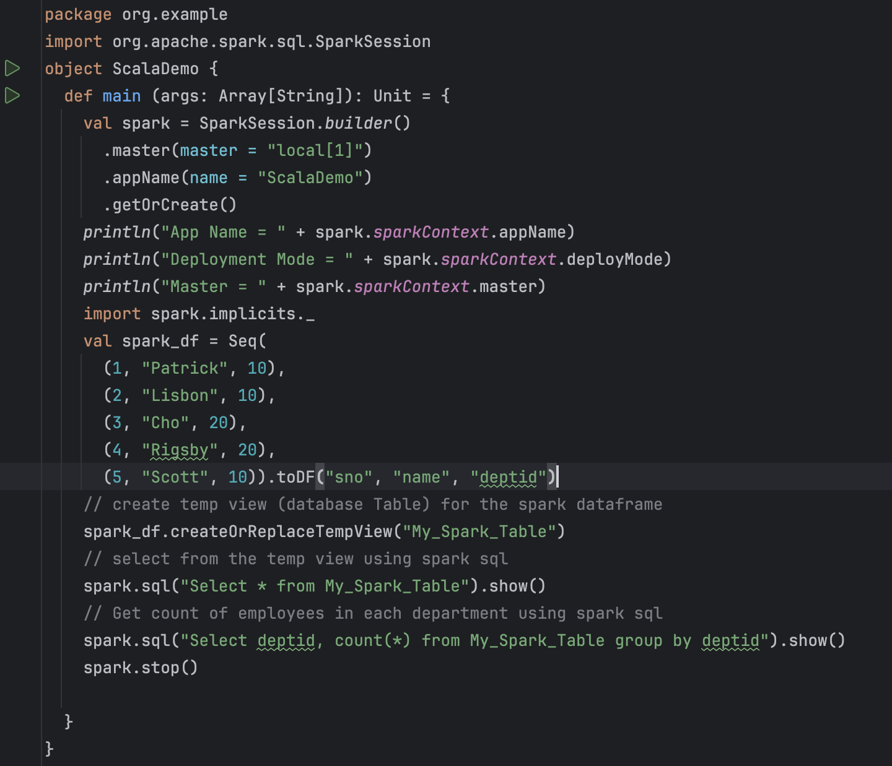

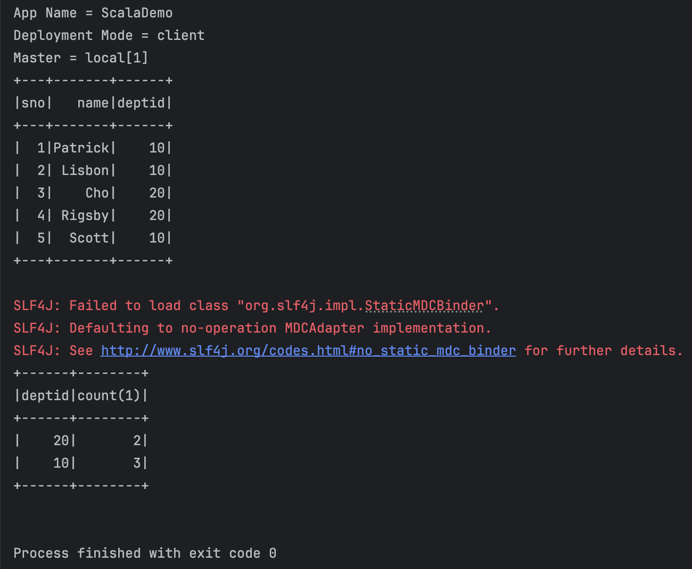

**Conclusion / Discussion**

• Spark SQL allows **seamless interaction with structured data**.

• Temporary **views** enable running SQL queries over Spark DataFrames.

• The GROUP BY query successfully aggregated **employee counts per department**.

• Future Improvements:

* Extend SQL queries to include **aggregations** like SUM(), AVG().
* Load **external data sources** instead of hardcoded values.
* Implement **window functions** for advanced analytics.

**Graph Processing Using GraphX in Scala**

**Statement of Problem**

The goal of this lab is to **build and analyze a social graph** using **GraphX**, where:

* **Users** are represented as **vertices**.
* **Relationships (follows)** are represented as **edges**.
* The graph structure is analyzed by counting **vertices, edges, and modifying attributes**.

**Explanation of Method/ Algorithm**

• Vertices **(Users):** Defined using a **case class User**, where each user has:

* id (Vertex ID)
* name
* age

• Edges **(Follows Relationships):** Represented using **directed edges (Edge class)**.

• Graph **Construction:**

* The **RDD-based approach** is used for **vertices and edges**.
* A **default user** ("NA", 0) is assigned for missing vertices.

• Graph **Operations:**

* **Count Vertices & Edges**
* **Modify Edge Attributes** ("follows" relationship)

**Complete Program/ Code**

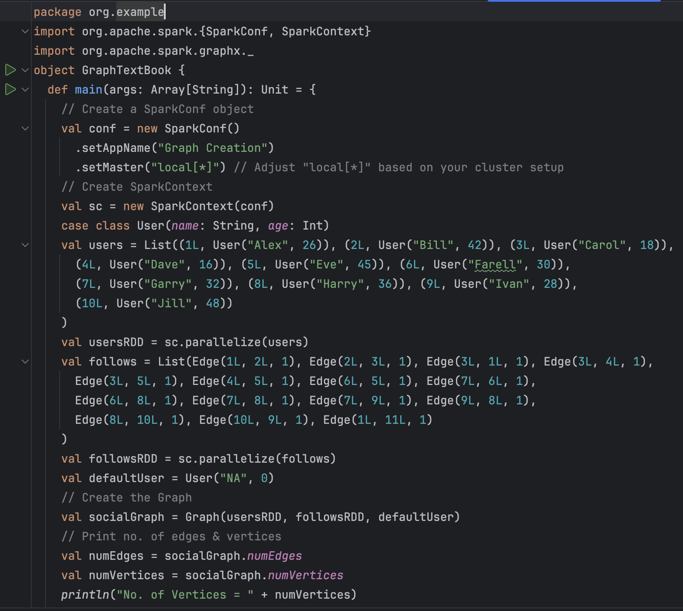

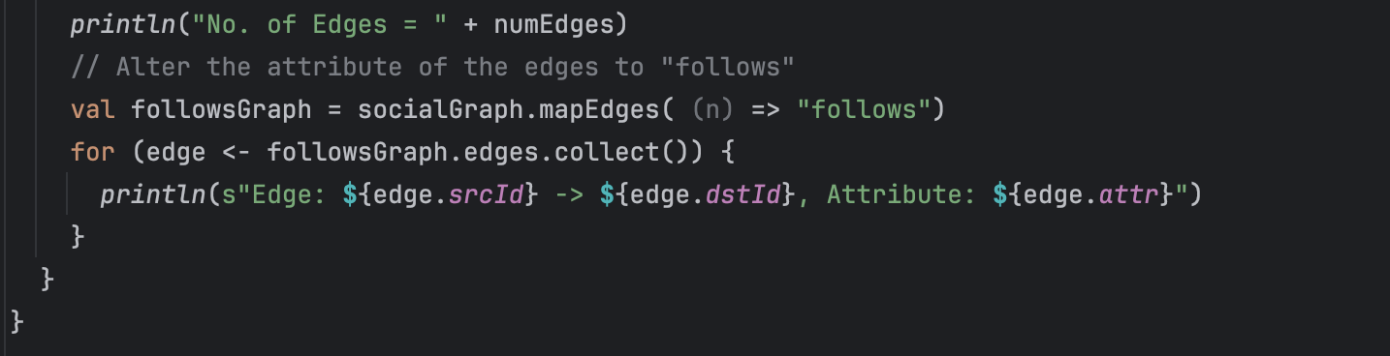

**Result:**

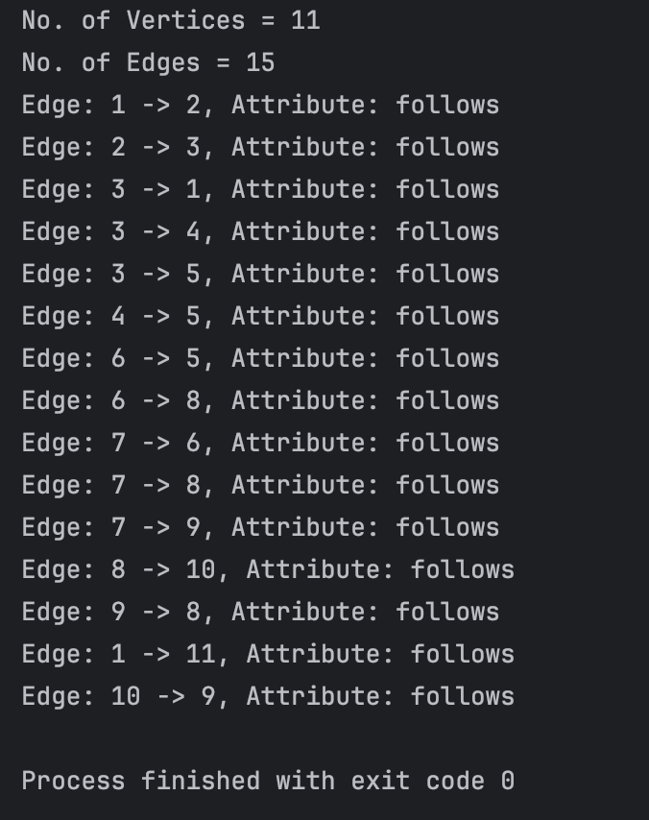

**Conclusion / Discussion**

* **GraphX successfully created and analyzed a social graph** with **users as vertices** and **relationships as edges**.
* **Graph transformations** (modifying edge attributes) were performed.
* **Potential improvements:**
  + Compute **degree centrality** (number of followers per user).
  + Implement **PageRank** to rank users by importance.
  + Apply **Connected Components** to find isolated user groups.

**Connected Components Using GraphX in Scala**

**Statement of Problem**

The objective of this lab is to identify **connected components** in a graph. A **connected component** is a subset of the graph where all vertices are **directly or indirectly connected**, and no additional vertex can be added while maintaining connectivity.

**Explanation of Method/ Algorithm**

• Vertices**:** Represent individuals (A to G) along with their **age**.

• Edges**:** Represent relationships (connections) between individuals.

• Graph **Construction:**

* **RDD-based approach** for defining vertices and edges.
* **GraphX API** is used to build the graph.

• Connected **Components Algorithm:**

* Finds **groups of connected vertices**.
* Each vertex gets a **component ID**, representing the smallest vertex ID in its connected group.
* The final output maps **each vertex to its component ID**.

**Complete Program/ Code**

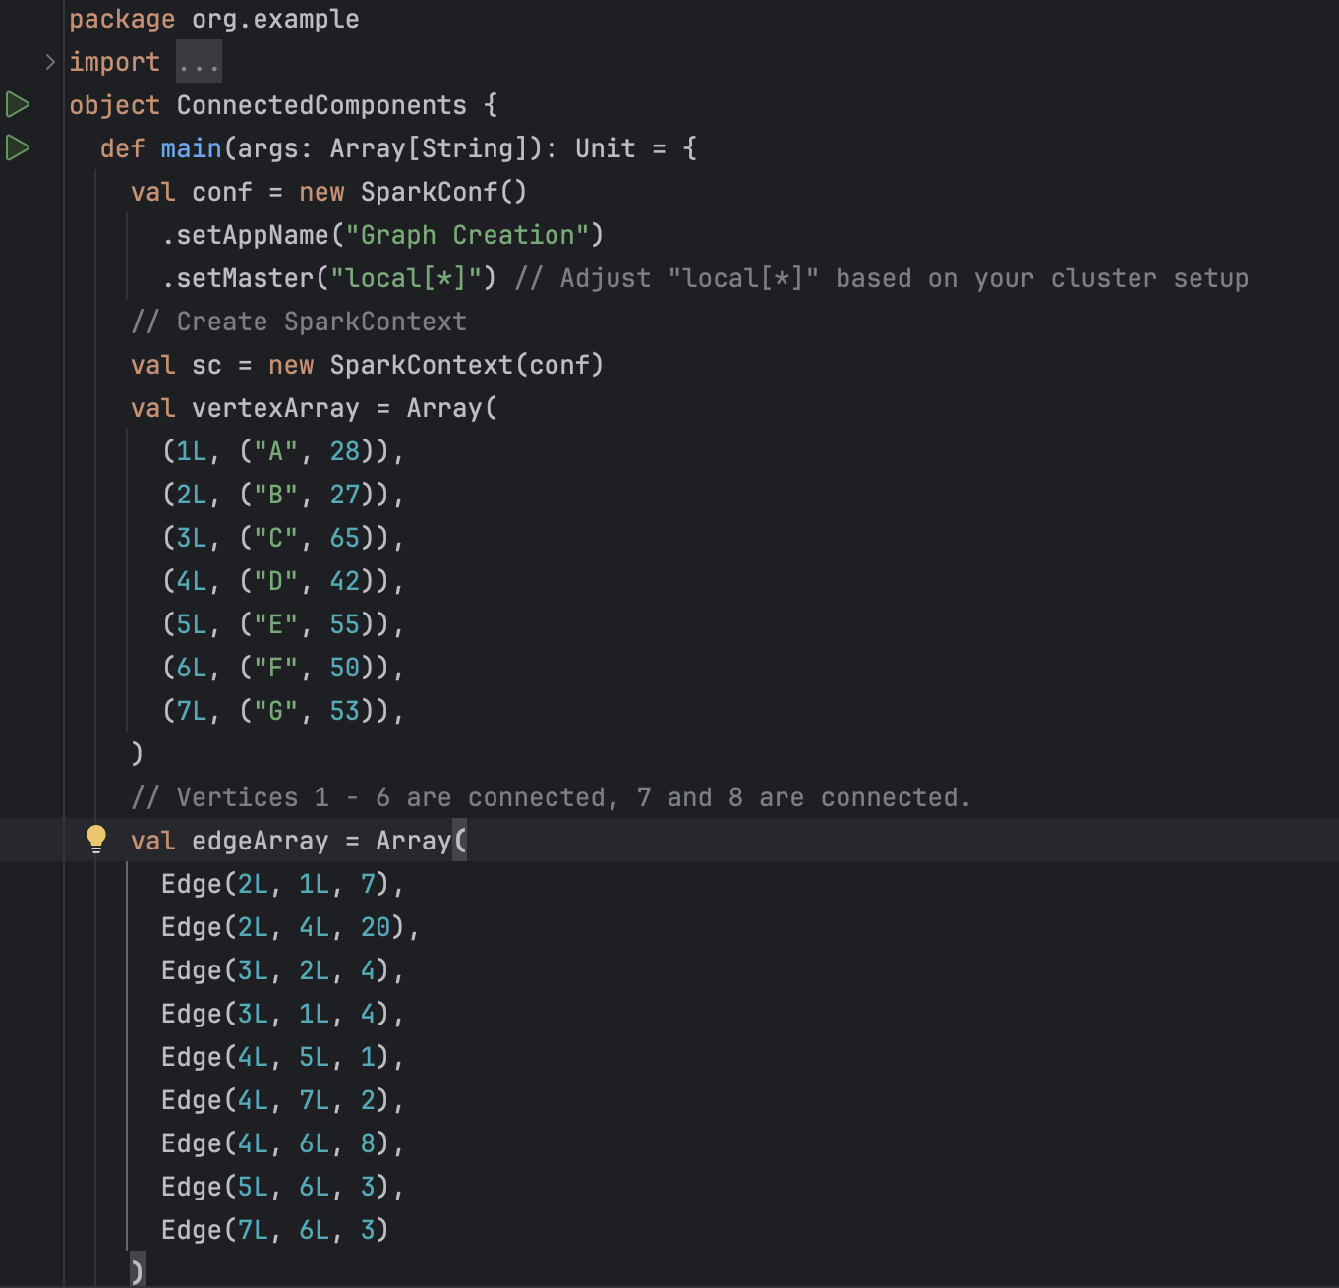

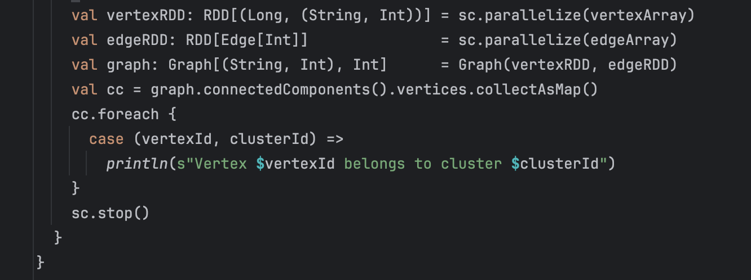

**Result:**

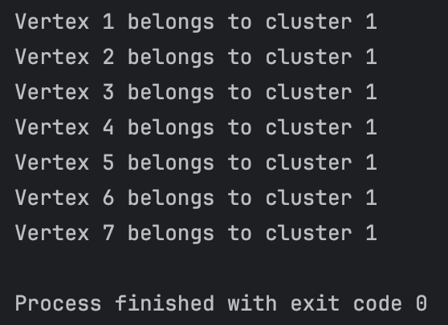

**Conclusion/ Discussion**

* The **Connected Components Algorithm** successfully grouped **connected vertices**.
* The **component ID represents the smallest vertex in each cluster**.
* **Disconnected nodes** form **separate components**.
* **Potential Improvements:**
  + Use **real-world datasets** (e.g., social networks, transportation networks).
  + Implement **other graph algorithms** like **Shortest Paths** or **Triangle Counting**.
  + Apply **graph partitioning** to optimize performance.

**Connected Components Using GraphFrames in PySpark**

**Statement of Problem**

The goal of this lab is to **identify connected components in a graph** using **GraphFrames**, which helps find **clusters of connected nodes**.

**Explanation of Method/ Algorithm**

• Graph **Construction:**

* **Vertices:** Represent nodes (a, b, c, d).
* **Edges:** Represent relationships (a → b, b → c, c → d).

• Connected **Components Algorithm:**

* Assigns **a component ID** to each node.
* Nodes in the same **connected component** share the **same ID**.

• Graph **Processing using GraphFrames:**

* **GraphFrame.connectedComponents()** computes **clusters of connected nodes**.

**Complete Program/ Code**

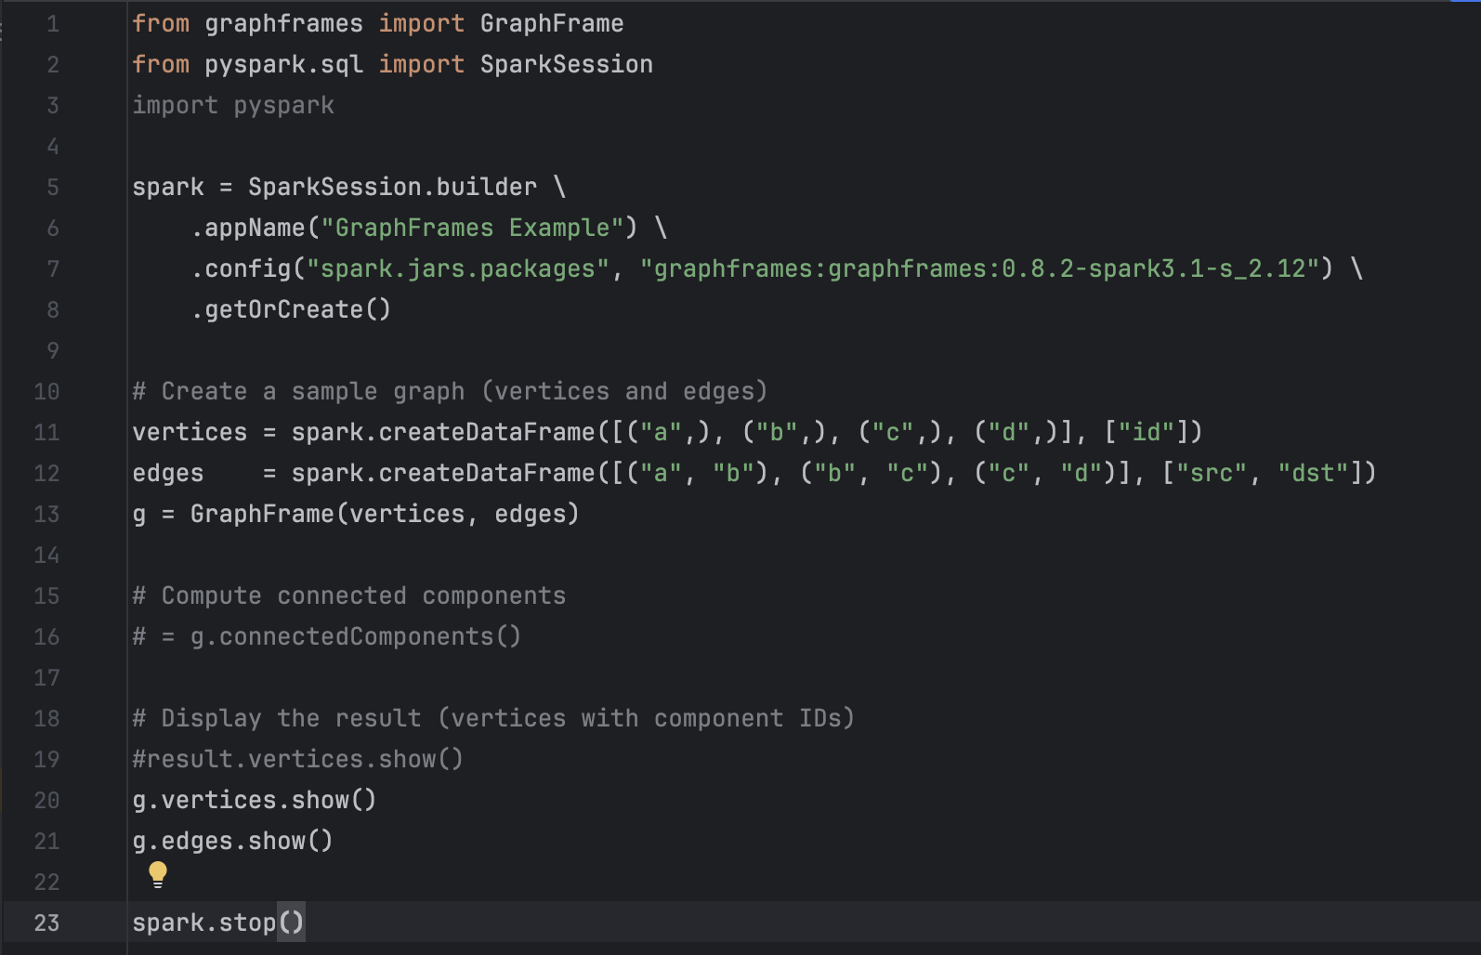

**Result:**

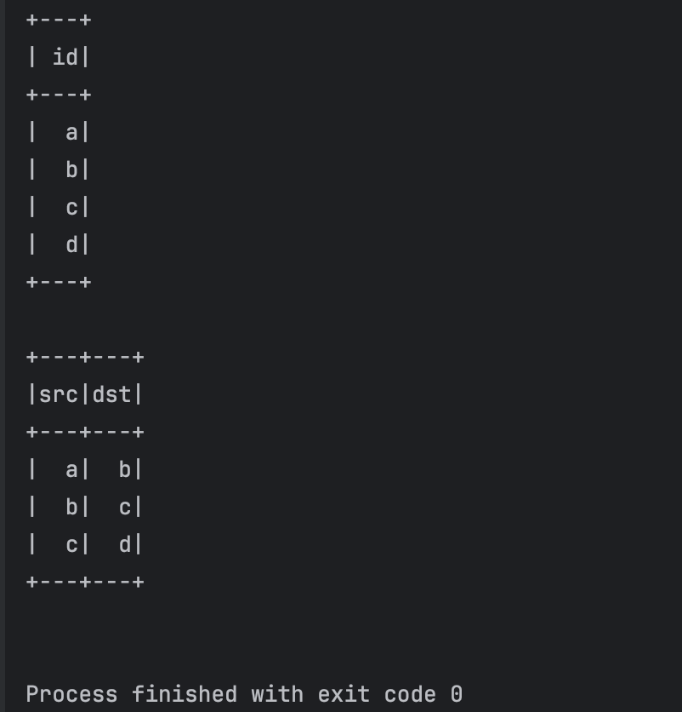

**Conclusion/ Discussion**

* **GraphFrames successfully identified connected components**.
* Nodes in the **same cluster** share the **same component ID**.
* **Potential Improvements:**
  + Use **larger datasets** for real-world graphs.
  + Experiment with **PageRank** or **Triangle Counting**.

**Facebook Data Analysis Using NetworkX**

**Statement of Problem**

The goal of this lab is to **visualize and analyze a Facebook social graph**, where:

* **Nodes represent users**.
* **Edges represent friendships**.

**Explanation of Method/ Algorithm**

• Dataset**:** facebook_combined.txt.gz (compressed file containing friendship data).

• Graph **Construction:**

* **Pandas** reads the dataset.
* **NetworkX (nx.from_pandas_edgelist)** constructs the **graph**.

• Graph **Visualization:**

* Uses **random layout** (nx.random_layout).
* Uses **spring layout** (nx.spring_layout) for better structure.

• Network **Statistics:**

* **Total nodes** (Facebook users).
* **Total edges** (Friendship connections).

**Complete Program/ Code**

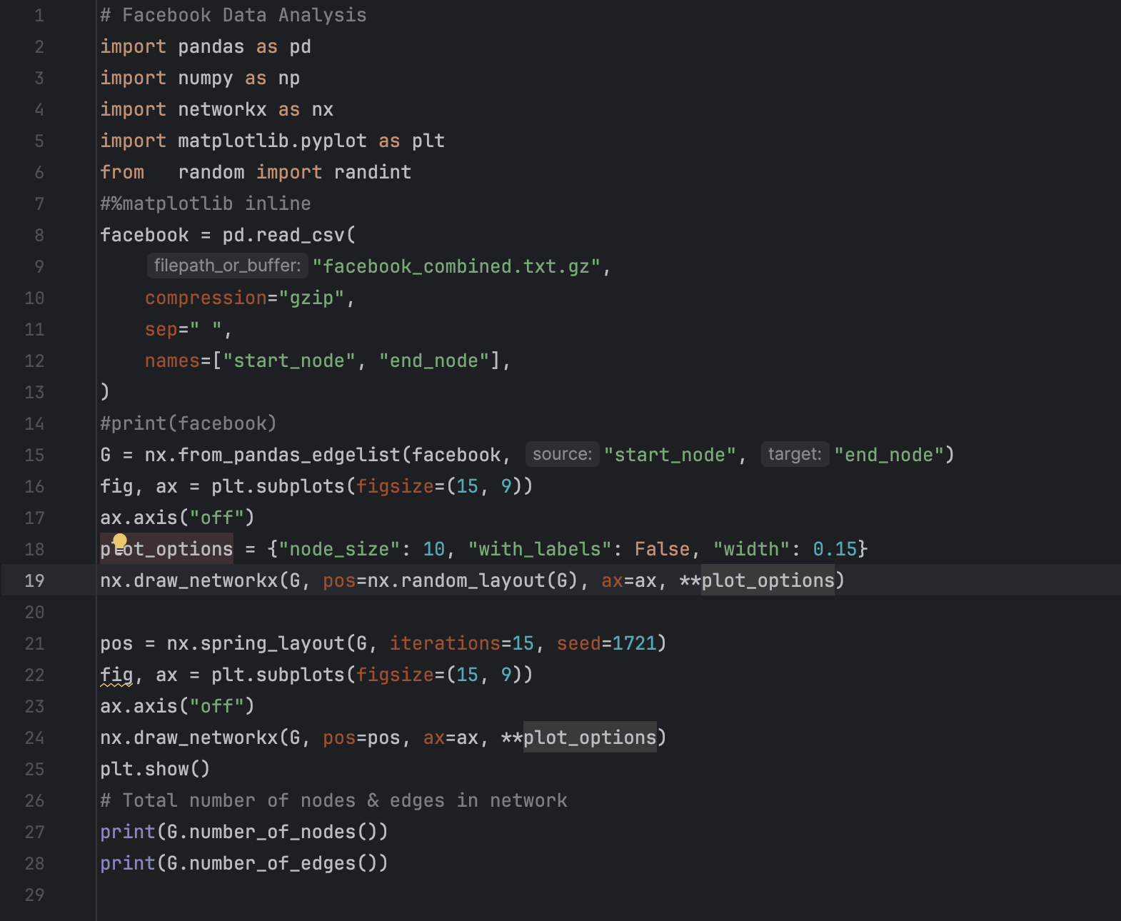

**Results:**

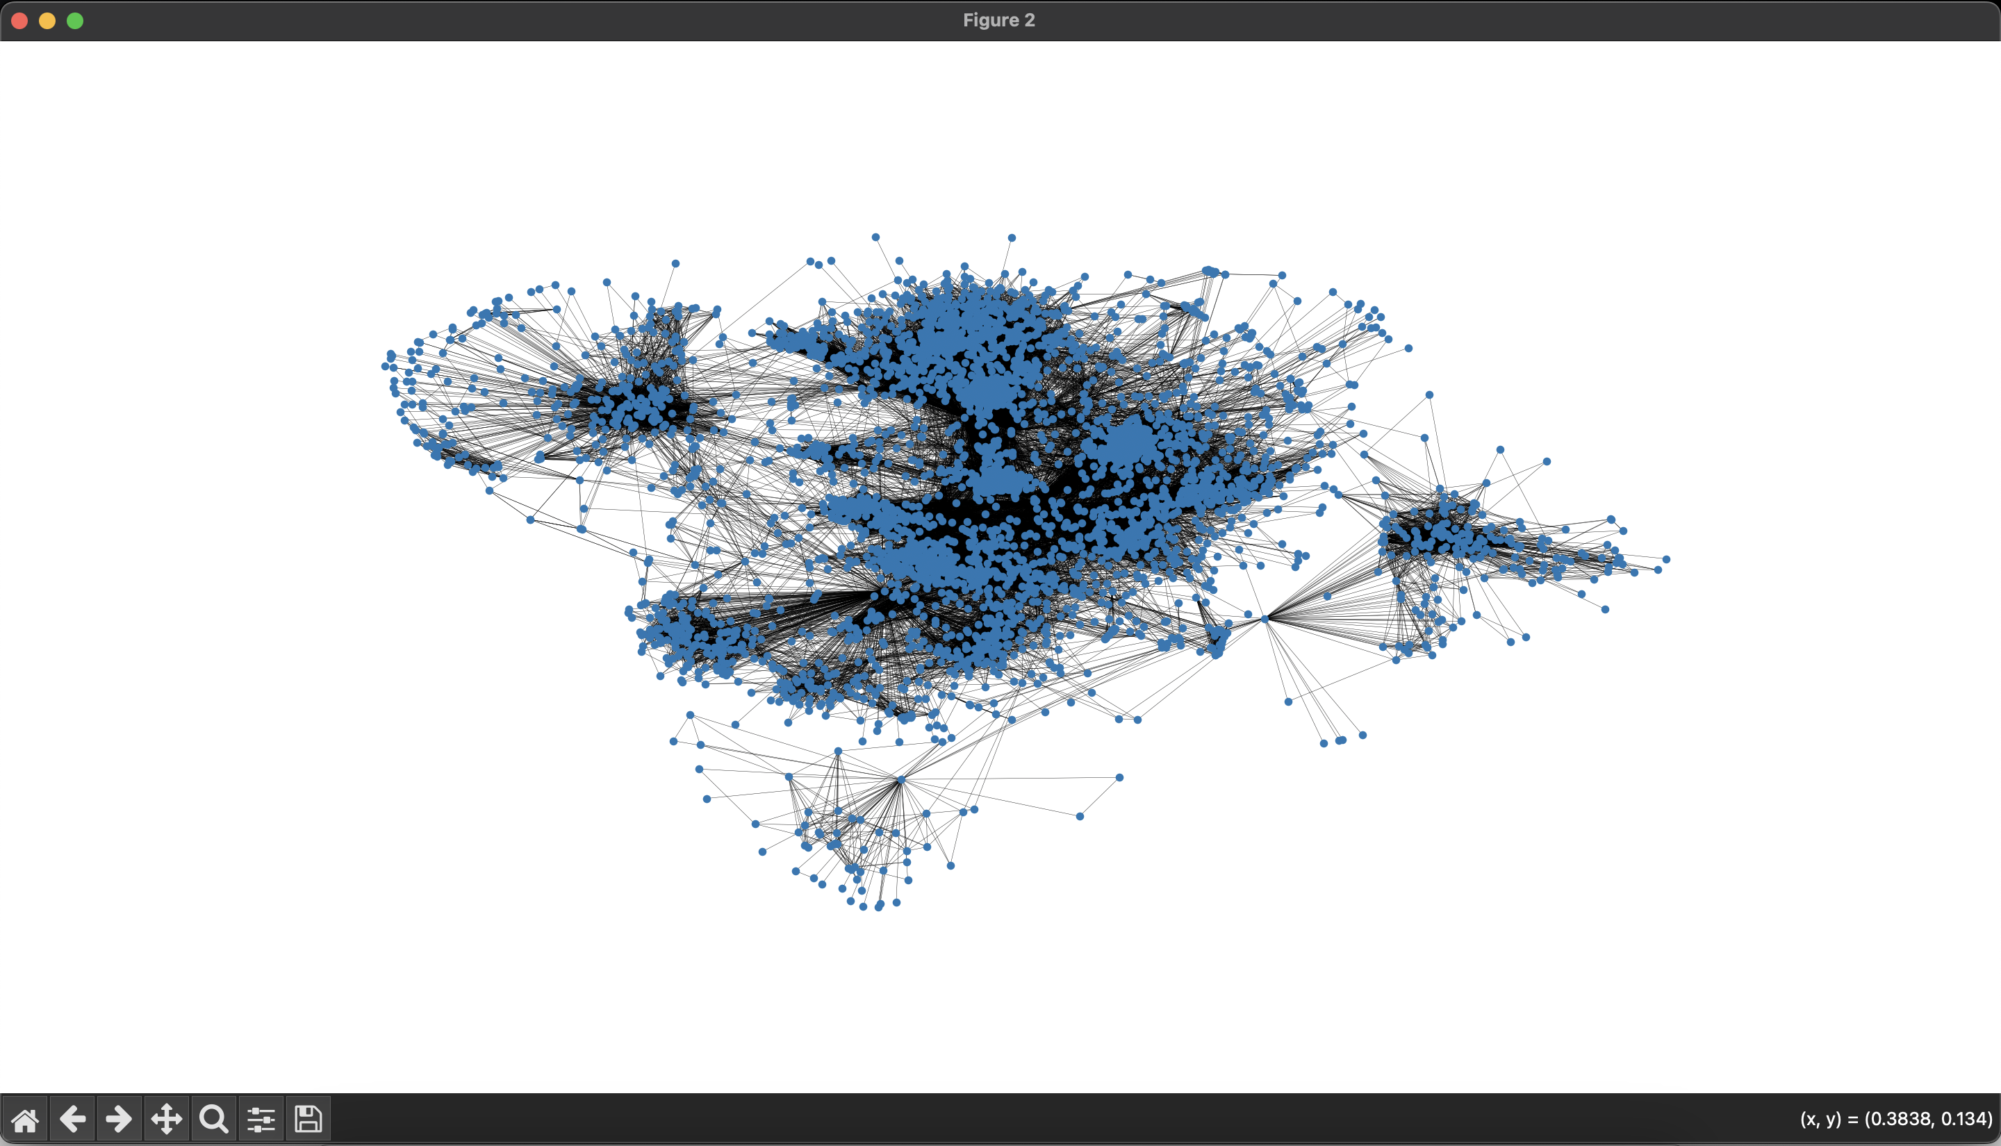

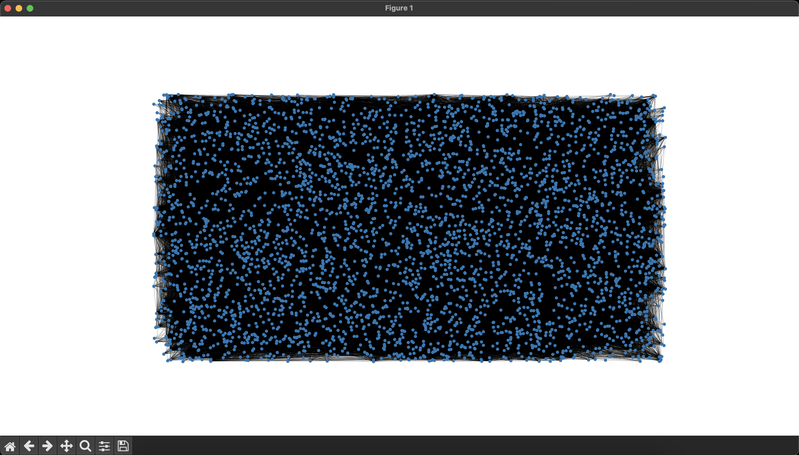

**Conclusion / Discussion**

• Network **successfully visualized the Facebook friendship graph.**

• The network consists of **thousands of users (nodes) and friendships (edges).**

• Spring **layout** gives a more structured representation of social clusters.

• Potential **Improvements:**

* Compute **Degree Centrality** (most connected users).
* Apply **Community Detection** (e.g., Louvain algorithm).
* Analyze **shortest paths and network density**.

**Graph Analysis Using GraphFrames and NetworkX**

**Statement of Problem**

The objective of this lab is to:

* **Construct a social graph** using GraphFrames.
* **Compute PageRank** to rank influential users.
* **Extract subgraphs** to filter specific relationships.
* **Run Breadth-First Search (BFS)** to find shortest paths.
* **Detect communities** using **Edge Betweenness Centrality**.
* **Visualize the network** using NetworkX.

**Explanation of Method/ Algorithm**

• Vertices**:** Users (Alice, Bob, Charlie, Darwin).

• Edges**:** Represent friendships (friend), followers (follows), and likes (likes).

• Graph **Processing:**

* **PageRank**: Determines node importance.
* **Subgraph Extraction**: Filters edges related to Bob (id 2).
* **BFS (Shortest Path Search)**: Finds the shortest connection from Alice (id 1) to Darwin (id 4).
* **Community Detection**: Uses **Edge Betweenness Centrality** (Error in implementation).

• Graph **Visualization (NetworkX):**

* Converts the PySpark graph into a NetworkX graph.
* Plots the **social connections**.

**Complete Program/Code**

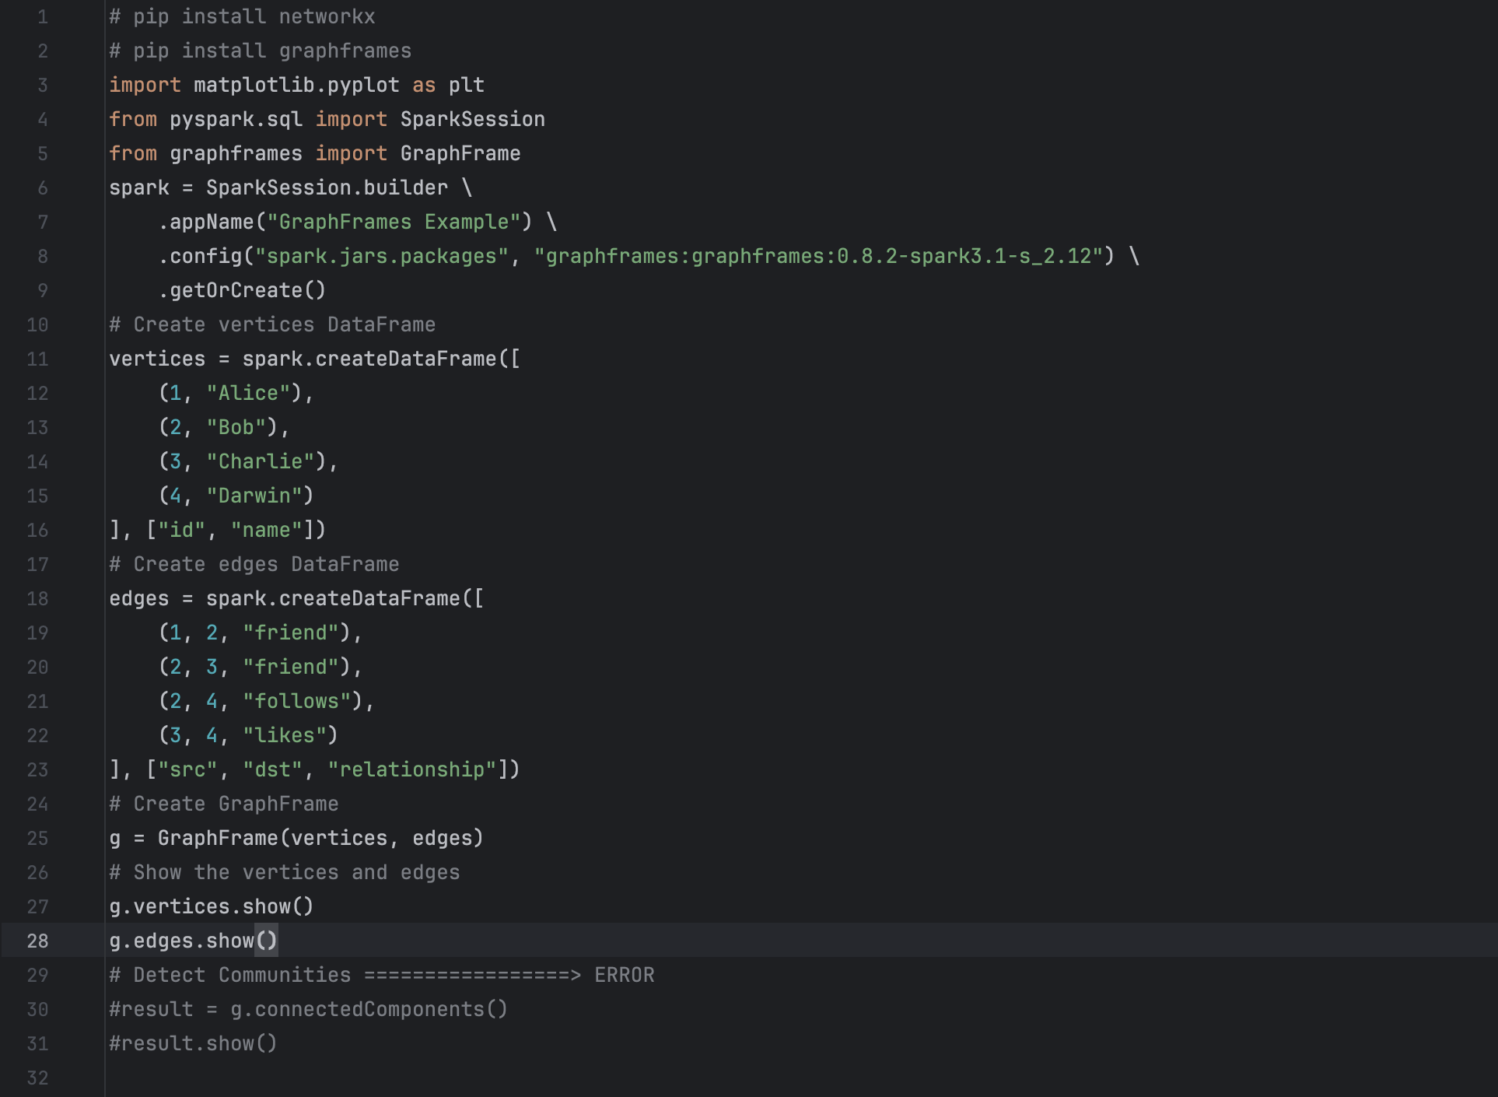

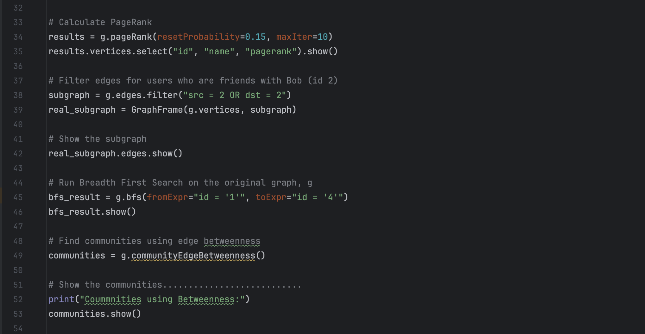

**Result:**

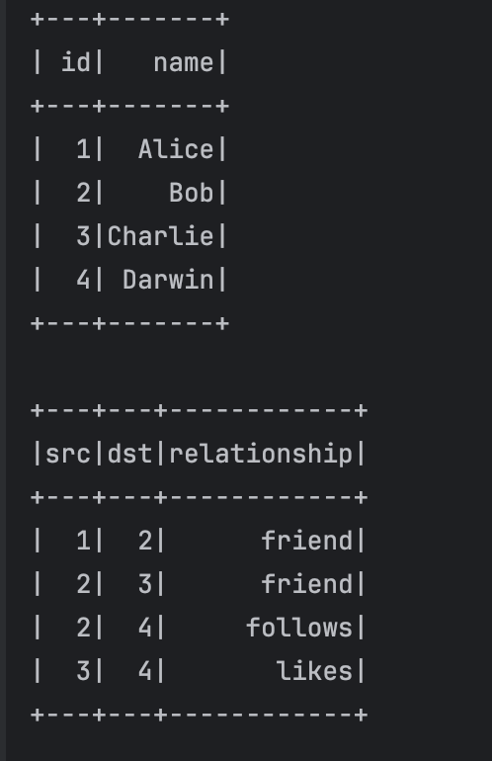

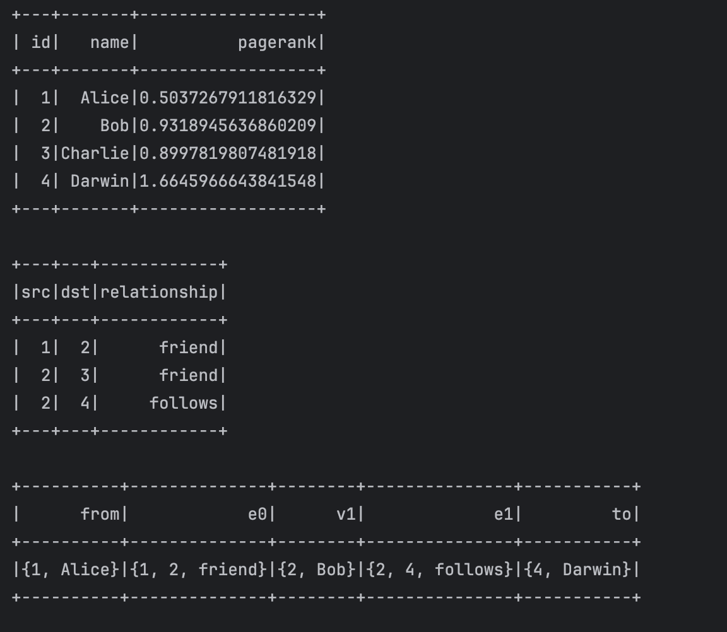

**Conclusion/ Discussion**

• Graph **Frames successfully processed the social network.**

• PageRank **identified influential users.**

• BFS **found the shortest path from Alice to Darwin.**

• Community **Detection using communityEdgeBetweenness() resulted in an error** (not available in GraphFrames).

• Network **visualization effectively represented the graph.**

• Potential **Improvements:**

* Implement **Connected Components** to find user groups.
* Try **alternative community detection methods**.
* Apply **centrality measures** like **betweenness** or **closeness centrality**.

**Graph Processing with GraphFrames and Pyspark**

**Statement of Problem**

The goal of this lab is to create a **graph from a set of vertices and edges**, perform analytics such as **PageRank** and **Breadth-First Search (BFS)**, and visualize the graph using networkx.

**Explanation of Method/ Algorithm**

• Libraries **Used:**

* GraphFrames: For graph creation and processing.
* NetworkX: For basic graph visualization.

• Vertices**:** Represent users (Alice, Bob, Charlie, Darwin).

• Edges**:** Represent relationships (friend, follows, likes) between users.

• Operations **Performed:**

* **PageRank**: Measures node importance based on incoming links.
* **Subgraph Extraction**: Filters edges involving Bob.
* **BFS**: Finds shortest path from Alice (id = 1) to Darwin (id = 4).
* **Graph Visualization**: A simple static representation using NetworkX.

**Complete Program/Code**

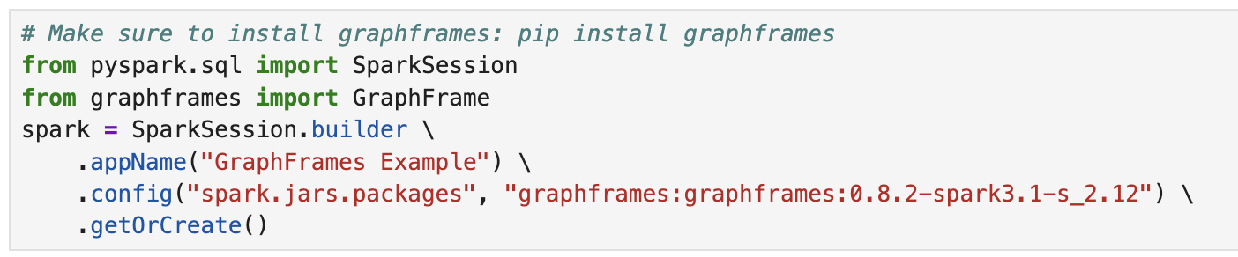

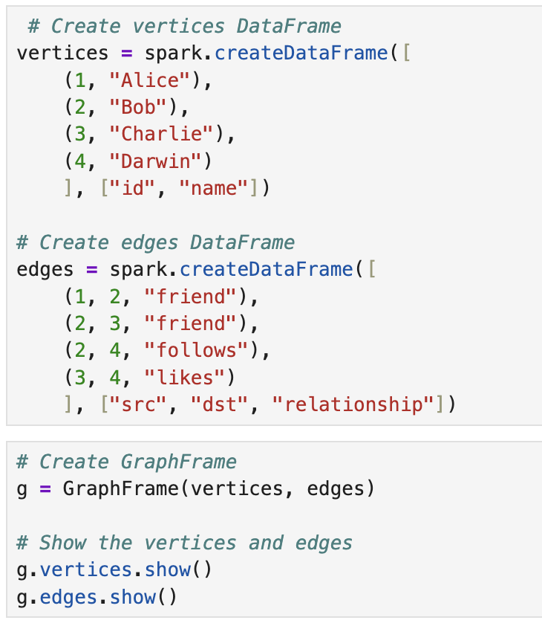

**Result:**

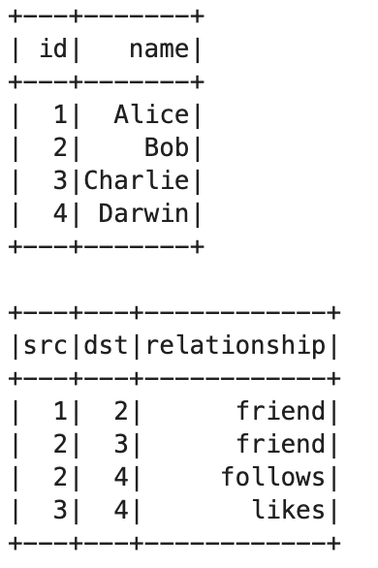

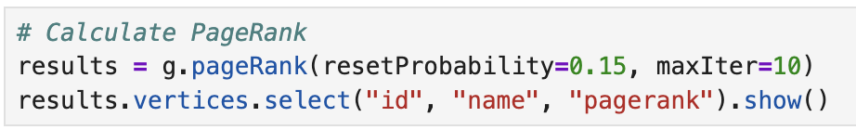

**Result:**

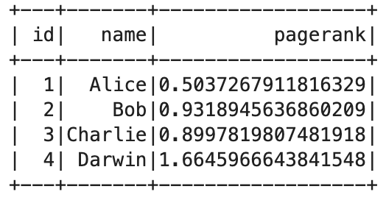

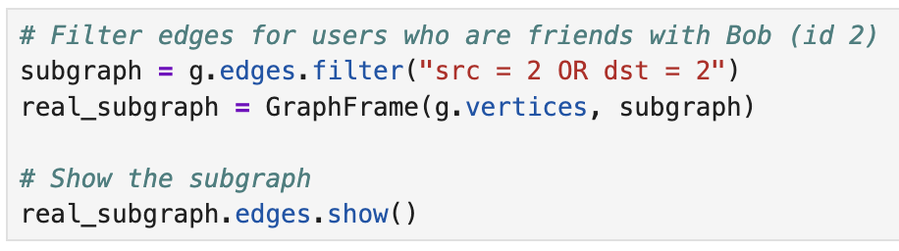

**Result:**

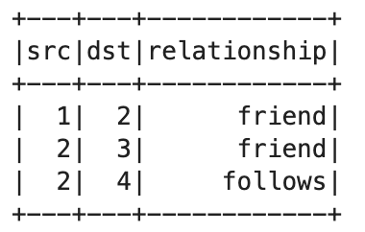

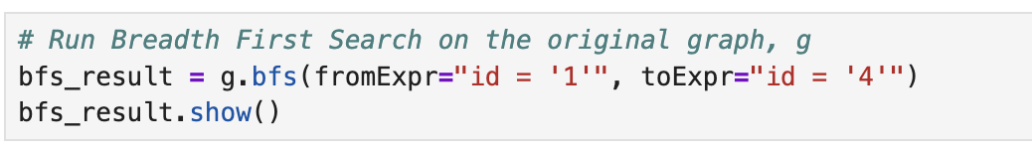

**Result:**

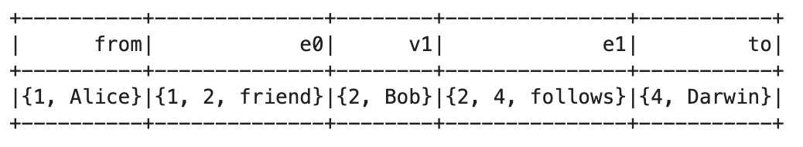

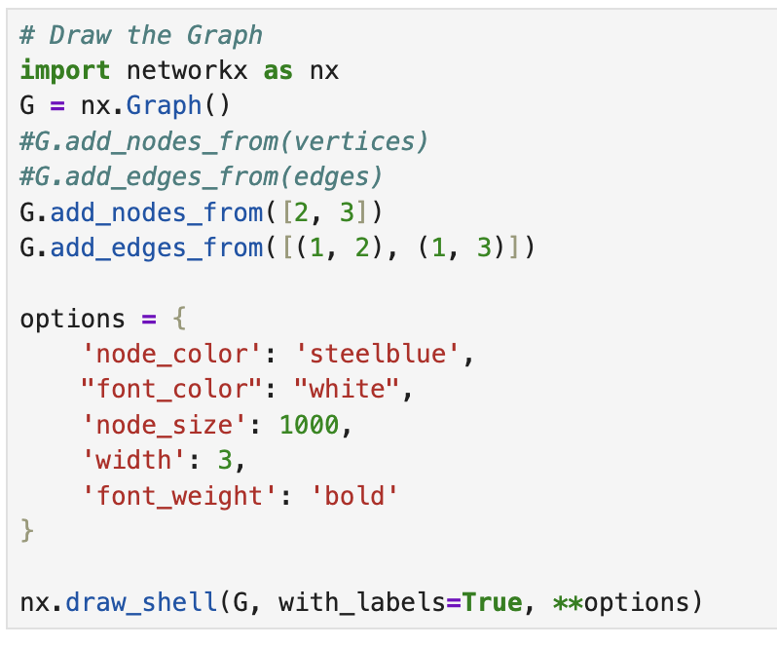

**Result:**

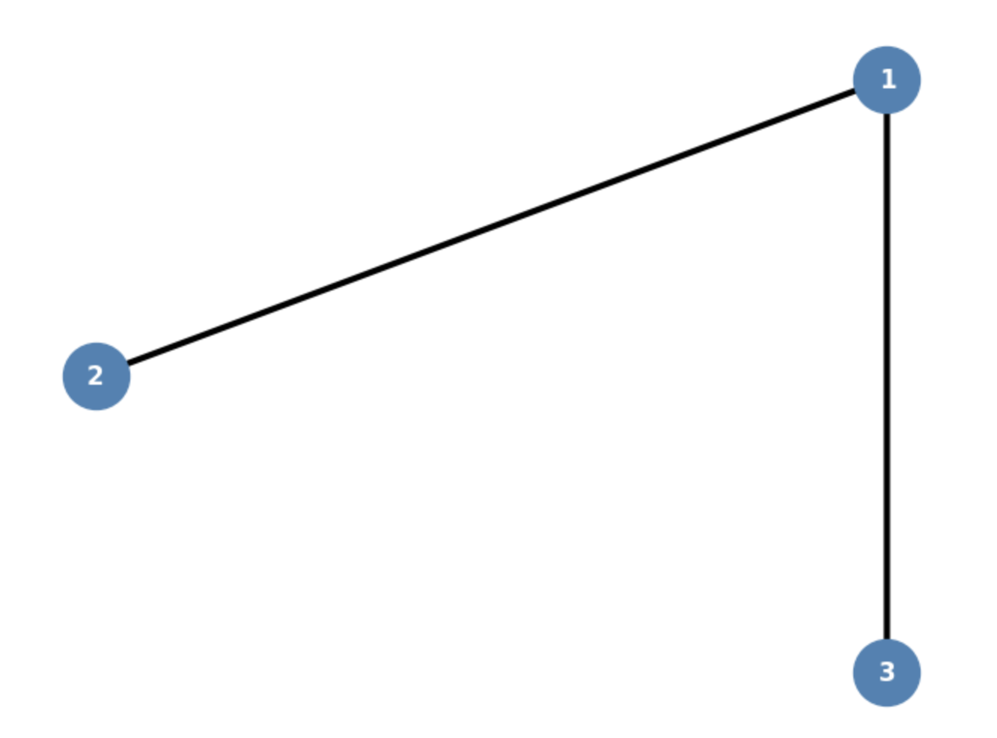

**Conclusion/ Discussion**

* **GraphFrames** enabled advanced graph processing like **PageRank** and **BFS** using Spark.
* The **NetworkX** plot visualized the relationships clearly.
* Potential Improvements:
  + Add more complex relationships and edge weights.
  + Explore **connected components**, **shortest paths**, or **triangle counting**.
  + Scale graph processing to **large social network datasets**.

**Spark SQL Dataframe Operations**

**Statement of Problem**

The objective of this lab is to demonstrate how to create a Spark DataFrame, convert it into a temporary SQL table, and perform SQL queries on the table. The goal is to retrieve data using Spark SQL queries and analyze the distribution of department IDs among employees.

**Explanation of Method/ Algorithm**

* **Initialize SparkSession**
  + A Spark session is created using SparkSession.builder(), with master set to "local[1]" for local execution.
* **Create a DataFrame**
  + A sequence of tuples representing employee data is created.
  + The sequence is converted into a DataFrame using toDF() with appropriate column names.
* **Create a Temporary SQL Table**
  + The DataFrame is registered as a temporary SQL view (createOrReplaceTempView) so it can be queried using SQL.
* **Execute SQL Queries**
  + The entire table is retrieved using SELECT * FROM My_Spark_Table.
  + A grouped count query is performed to determine the number of employees in each department (SELECT deptid, COUNT(*) FROM My_Spark_Table GROUP BY deptid).
* **Display Results**
  + The results of both queries are displayed using .show().
* **Stop Spark Session**
  + The Spark session is stopped to release resources.

**Complete Program/ Code**

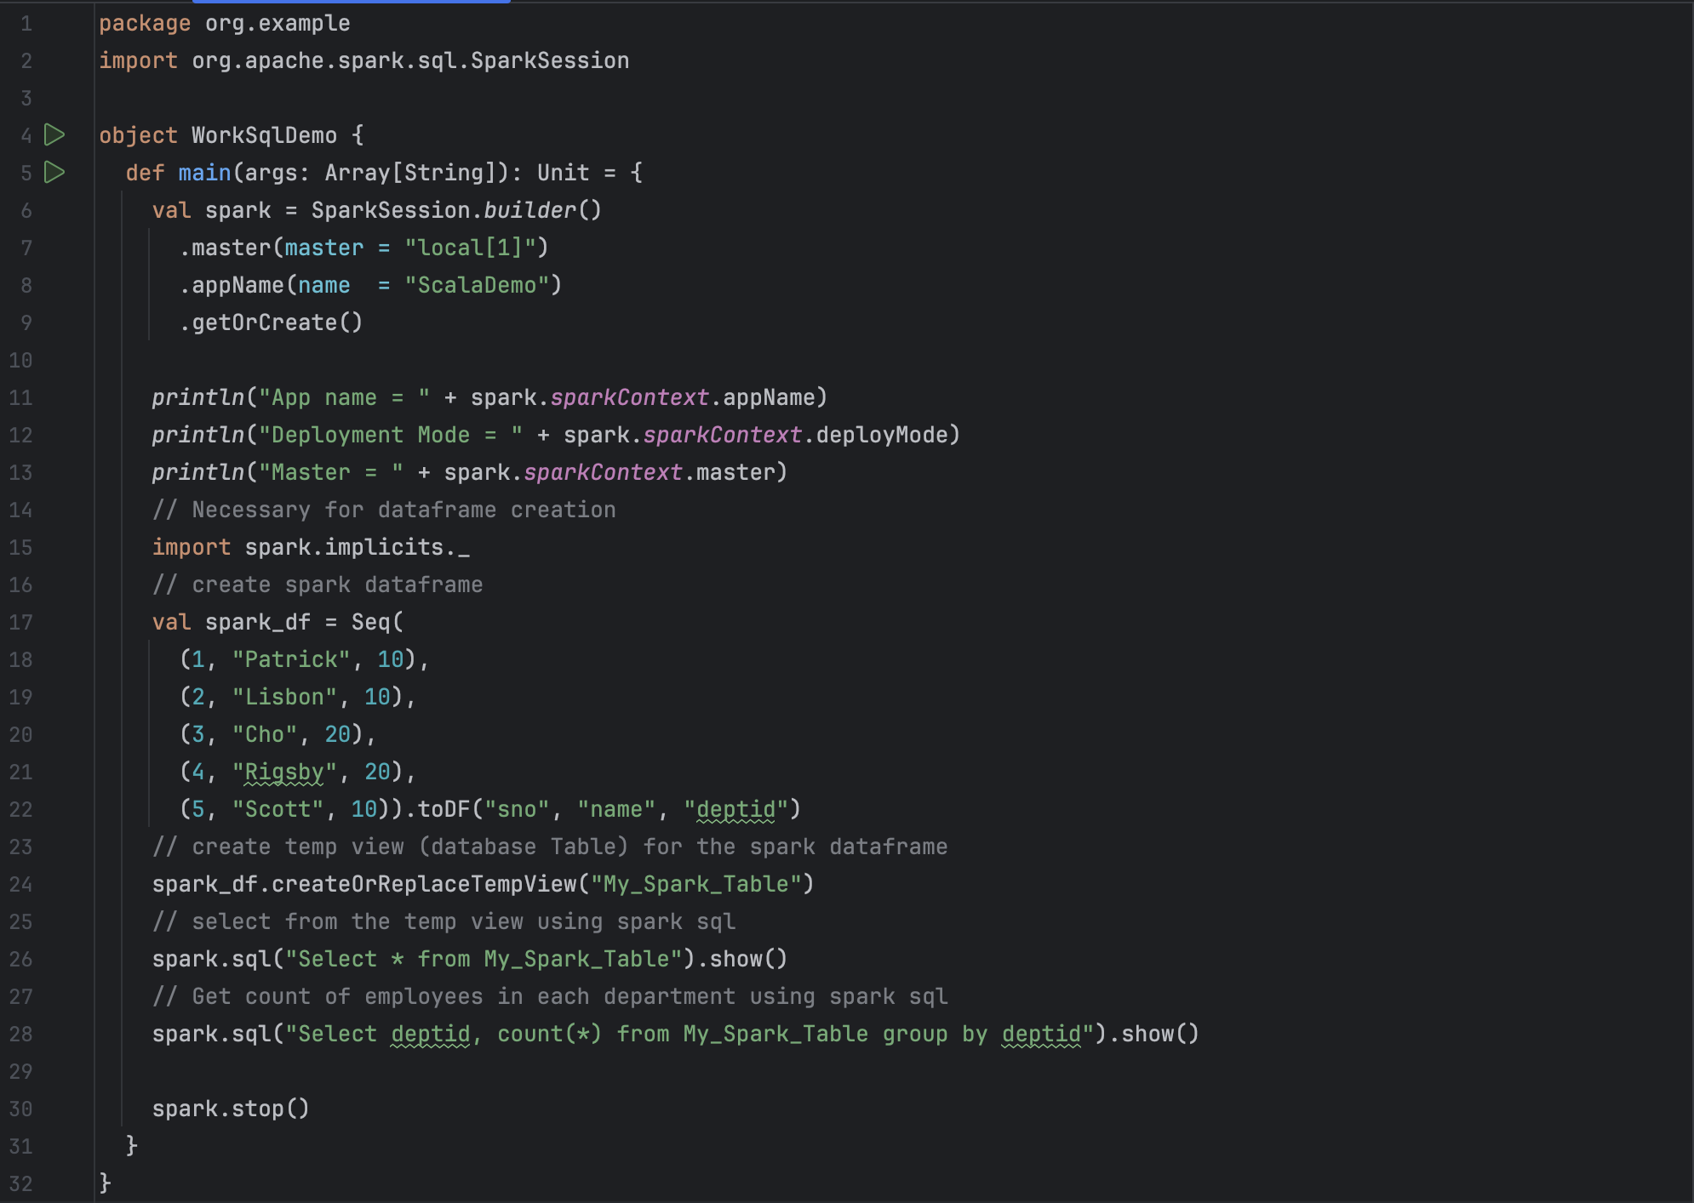

**Result:**

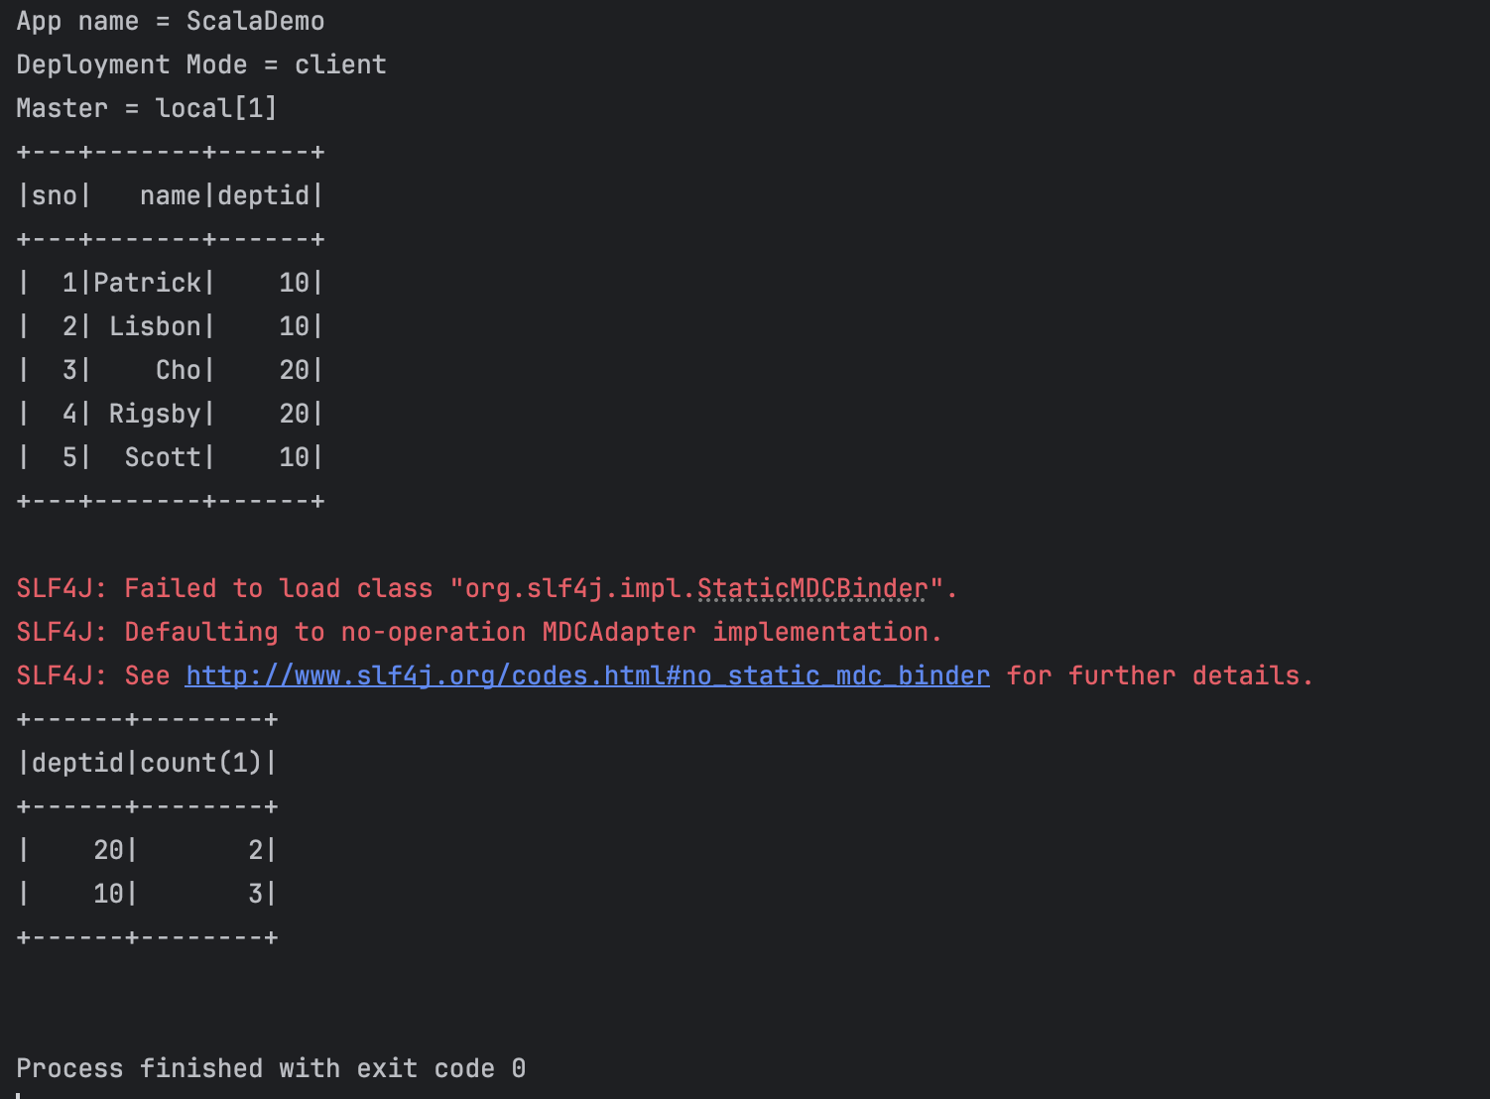

**Conclusion/ Discussion**

This lab demonstrated how to use Spark SQL to create a DataFrame, register it as a temporary table, and run SQL queries. The results confirm that:

* The DataFrame correctly stored and displayed the employee data.
* The SQL query successfully grouped and counted employees by department.
* The program executed successfully with minor logging warnings.
* Future improvements could include handling logging dependencies to avoid SLF4J warnings and implementing additional queries for deeper data analysis.